**Data Flows – Hospital Admissions Data Transformation**

**Source Transformation:**

* Create a new pipeline
* Before creating pipeline enable data flow debug
* Create a new dataset for the pipeline

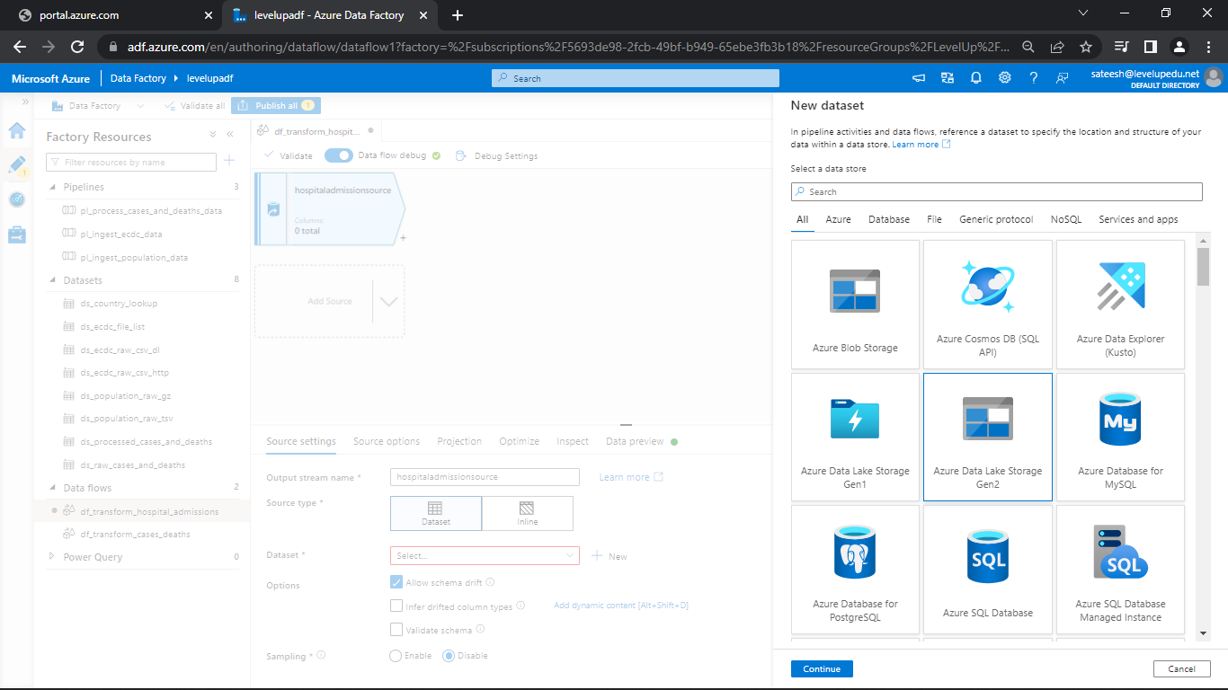

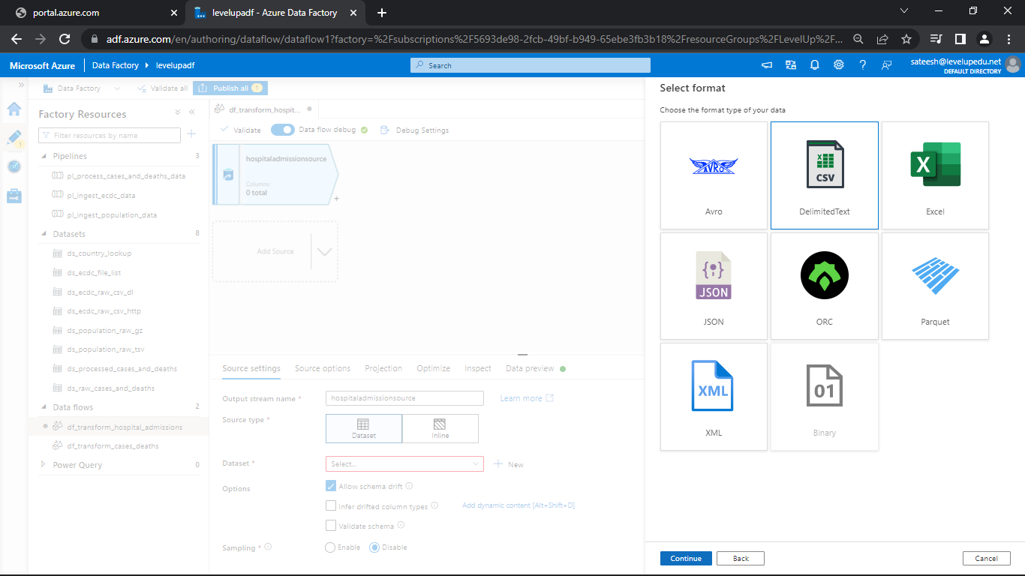

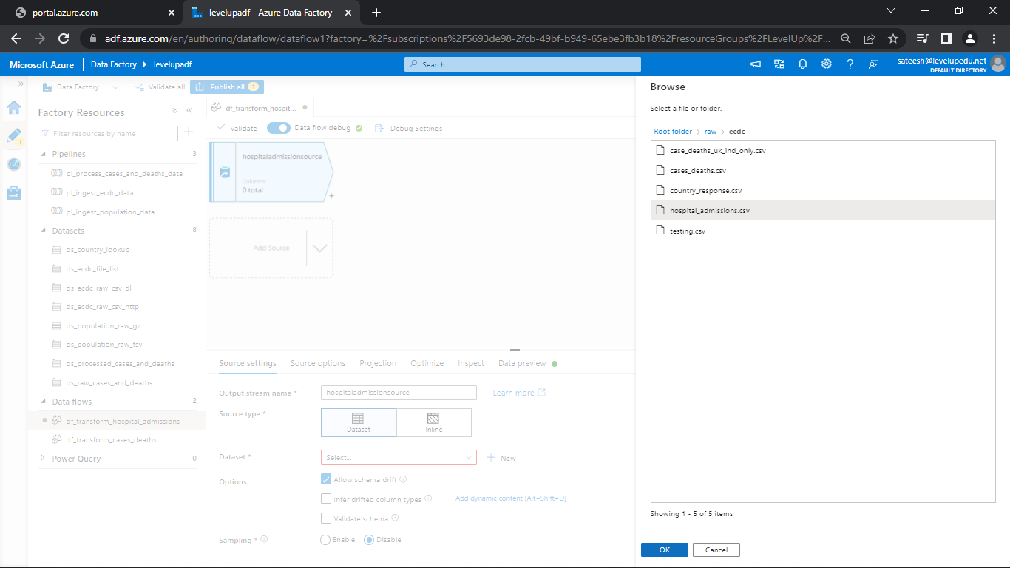

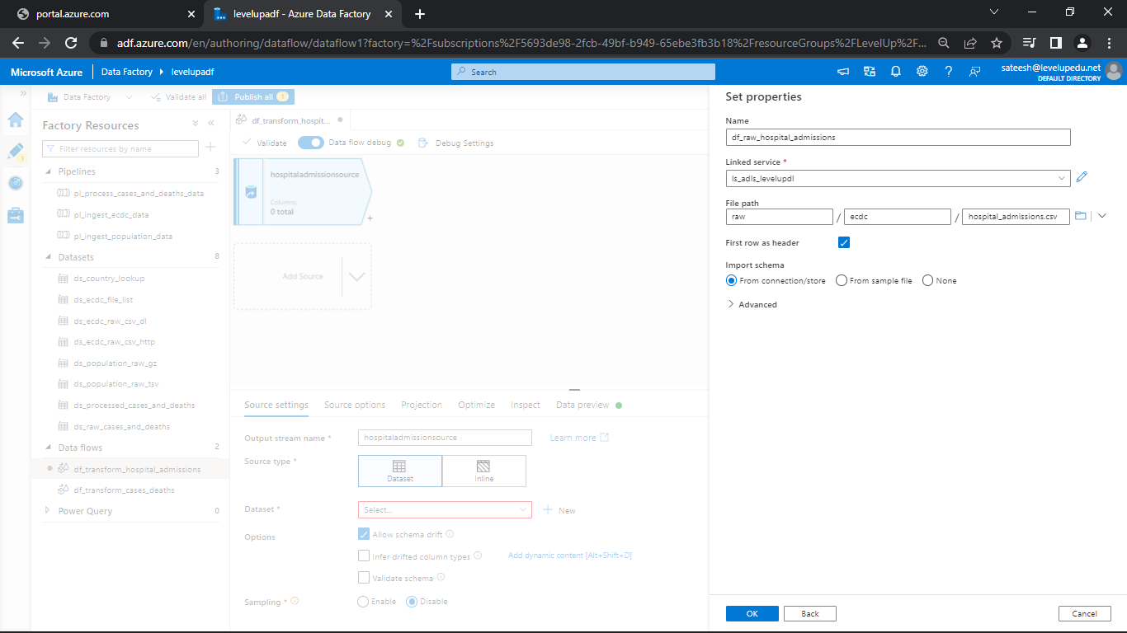

* Go to projection and click on detect data type

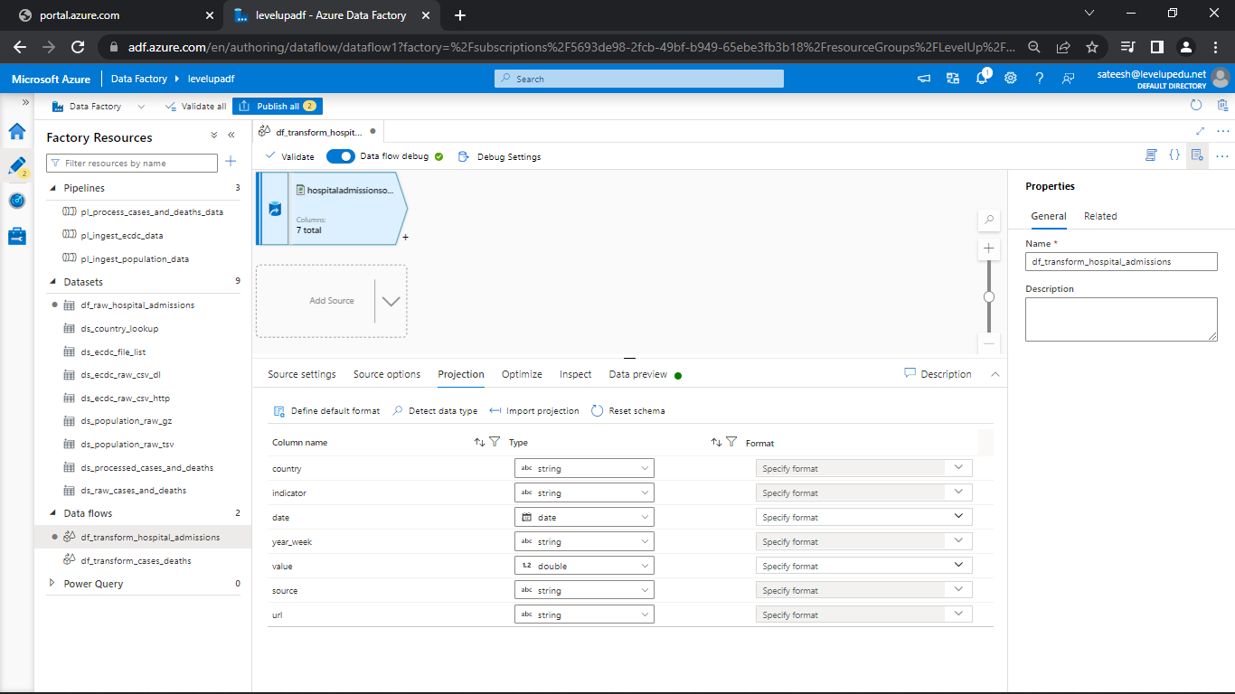

* Go to data preview and see the data

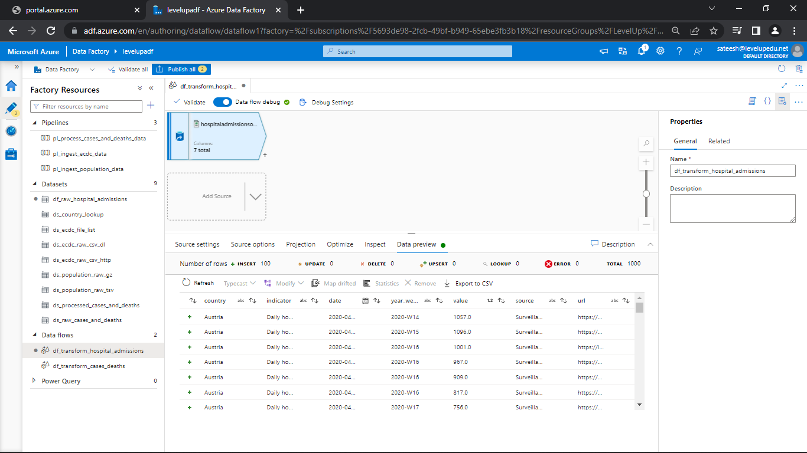

**Select Transformation:**

* Click on + and click on select transformation

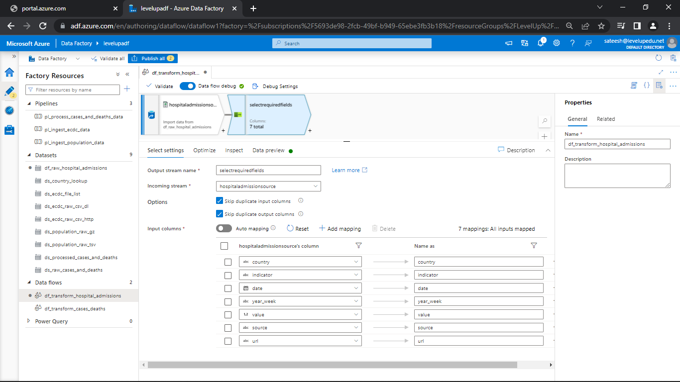

* Delete URL from columns
* Change the date and year if required

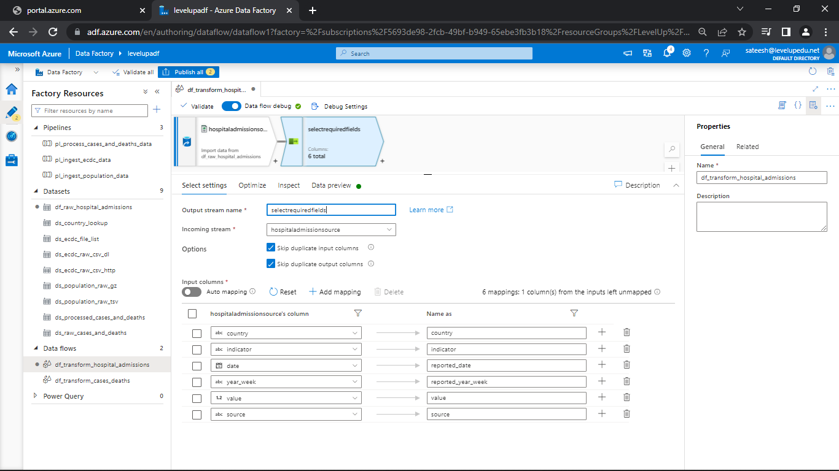

* Go to data preview

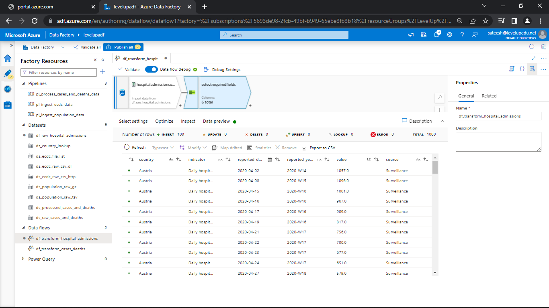

**Look Up Transformation:**

1. Create a Source and attach the dataset created before.

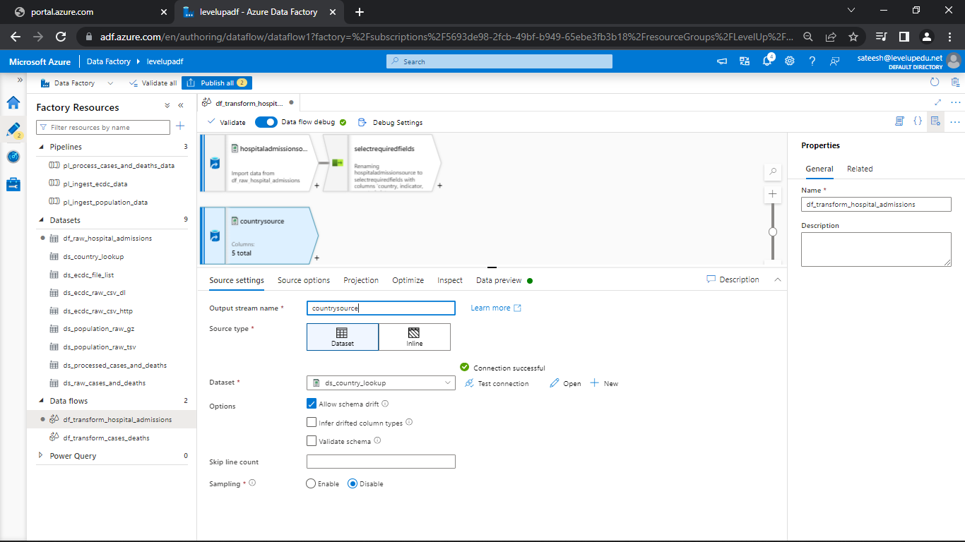

* Click on + and select look up transformation
* Attach the look up stream as countrysource

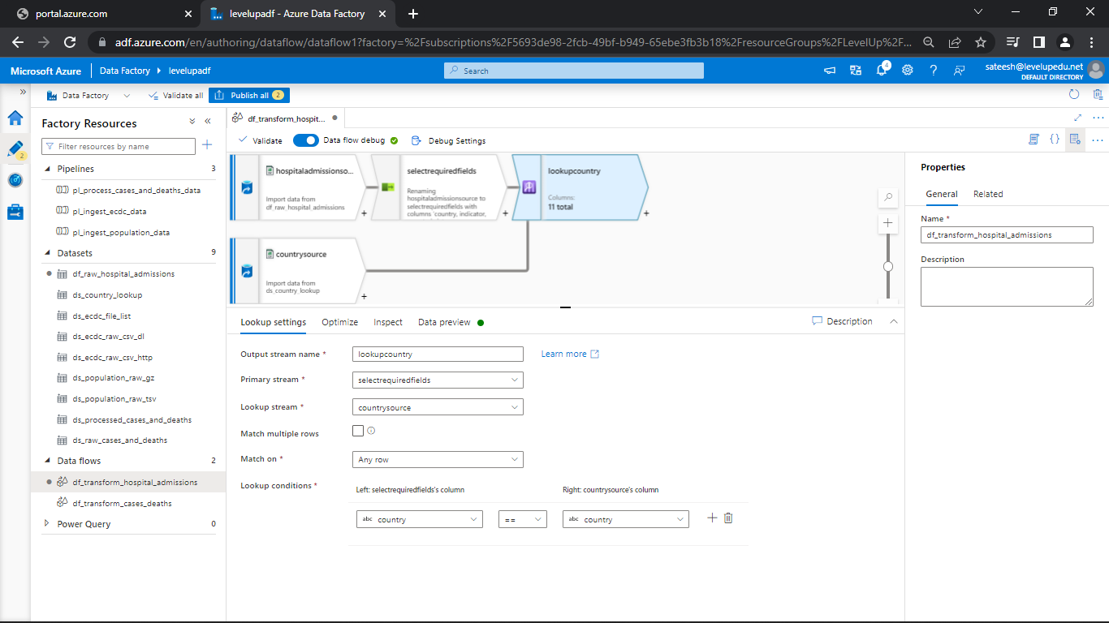

* As you can see there are so many columns in Optimize
* Let’s just remove some and select some by using select transformation

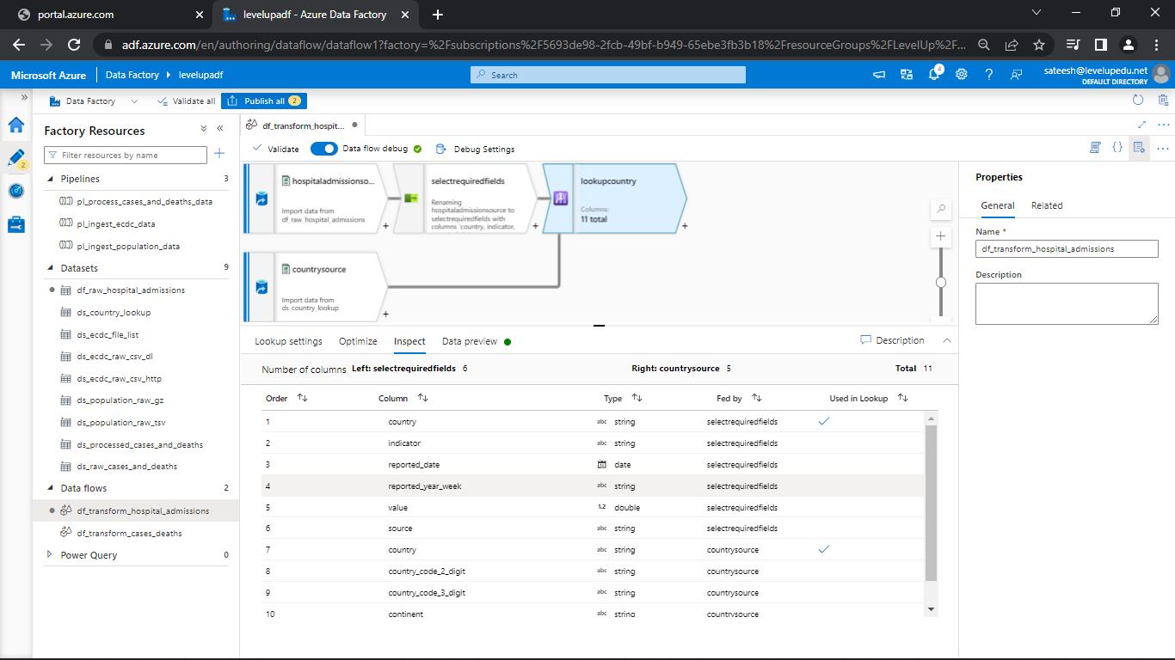

* Click on + and go to select transformation
* Remove the continents from columns

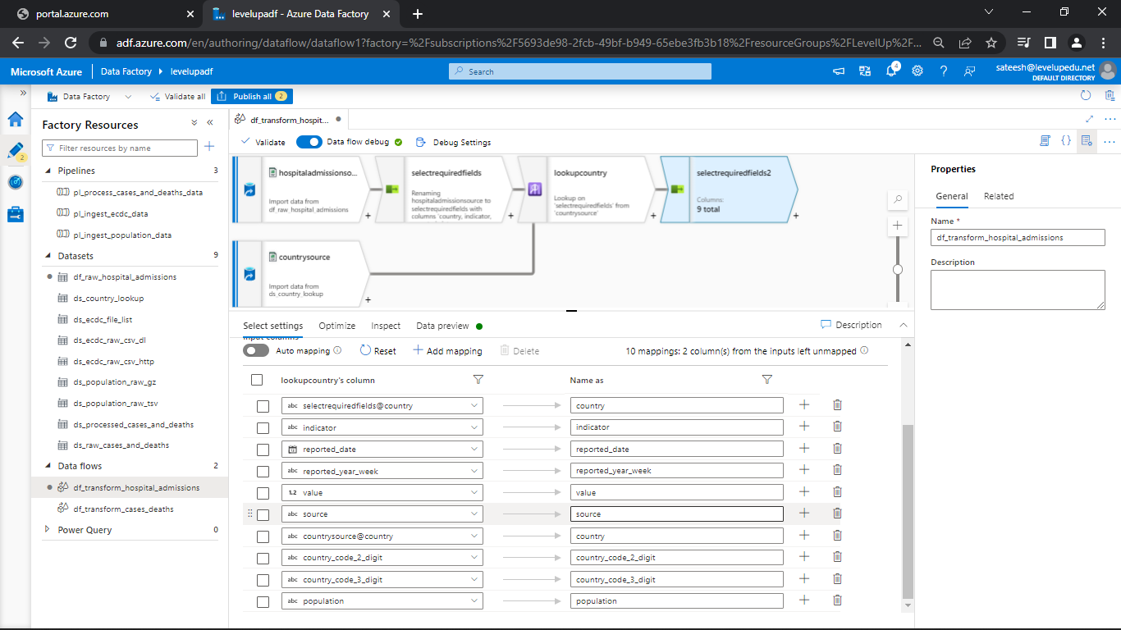

* Go to the data preview

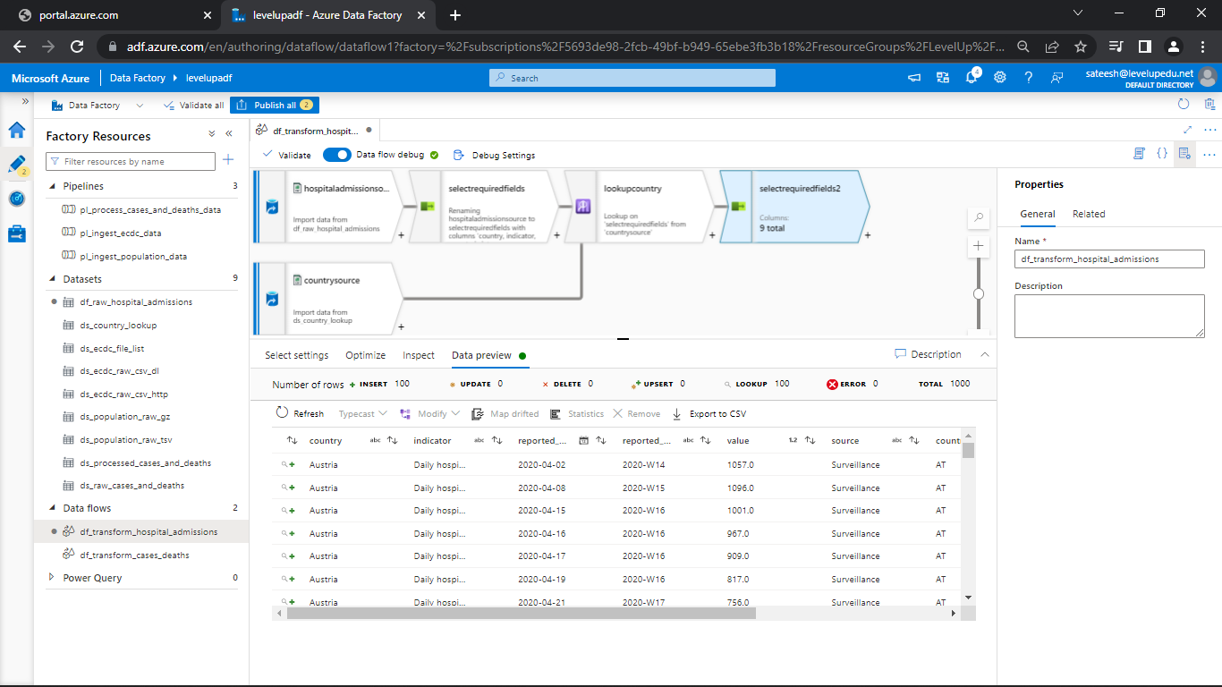

**Conditional Split Transformation:**

* Click on + next to select transformation and select conditional split transformation

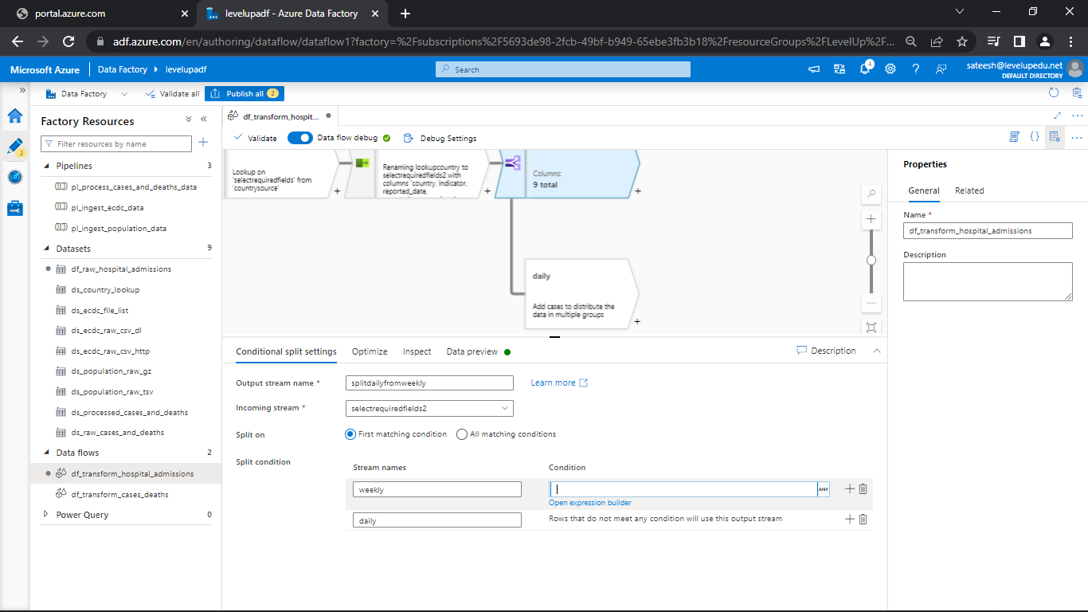

* Change the name if required
* Give the Split condition stream names and open expression builder and give the commands
* indicator == 'weekly new hospital admissions per 100k' || indicator == 'weekly new ICU admissions per 100k'

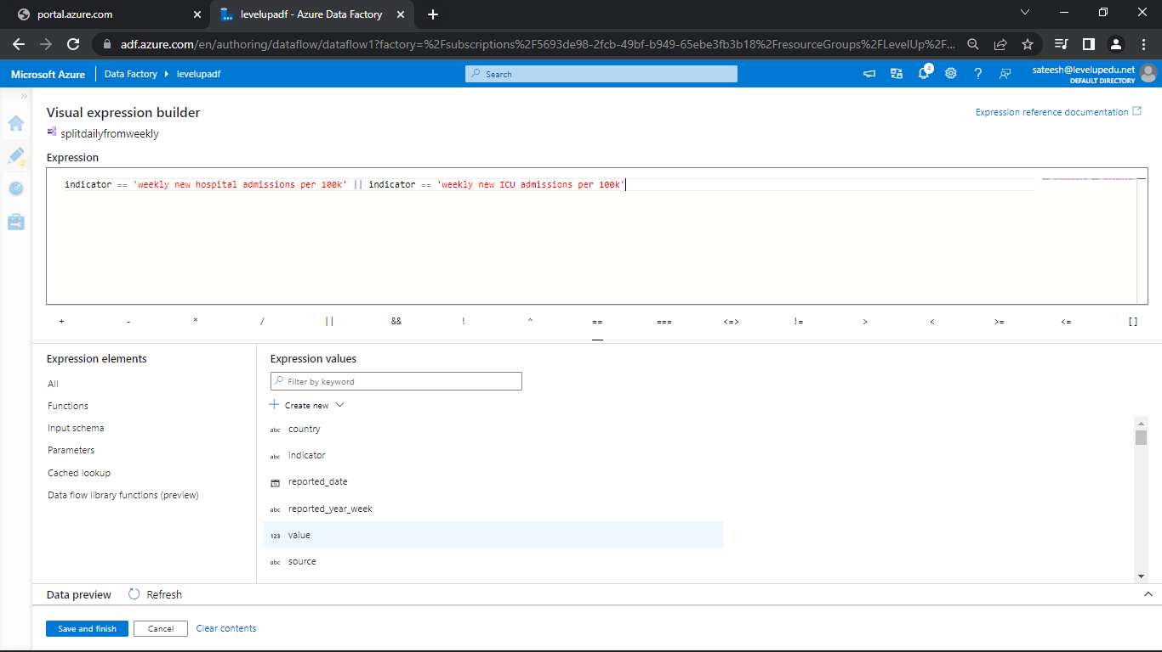

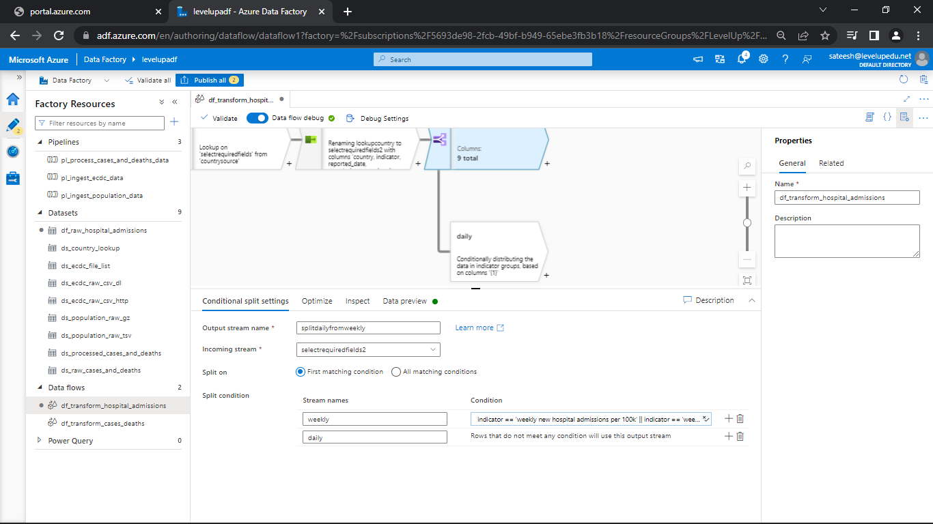

* Go to Data preview

**Source Transformation – DimDate:**

* Go to storage explorer and in lookups upload the file by name Dimdate

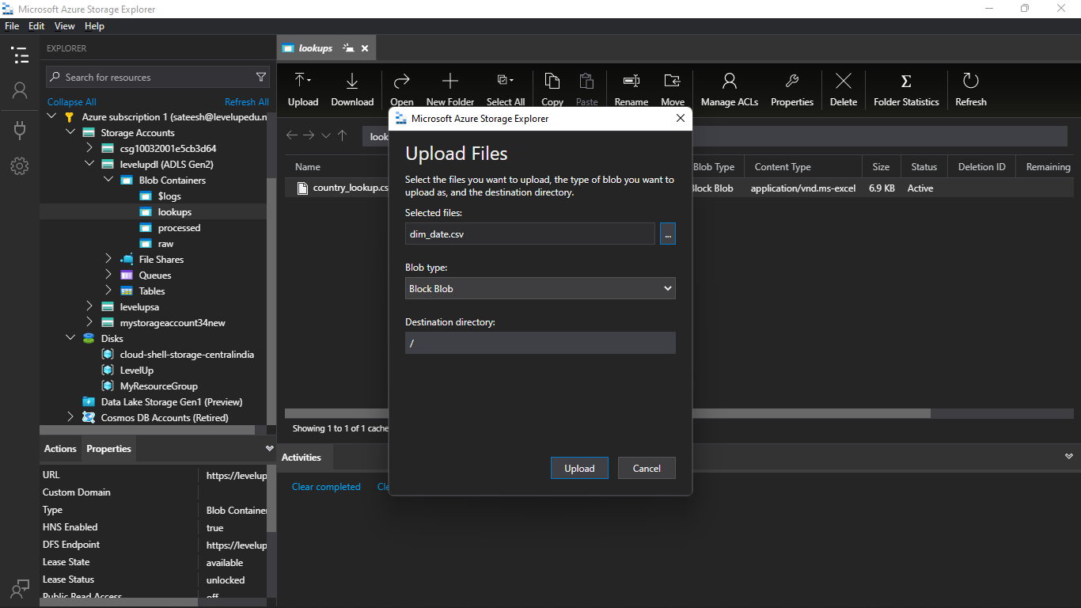

* Create a new source for dimdate and rename if required

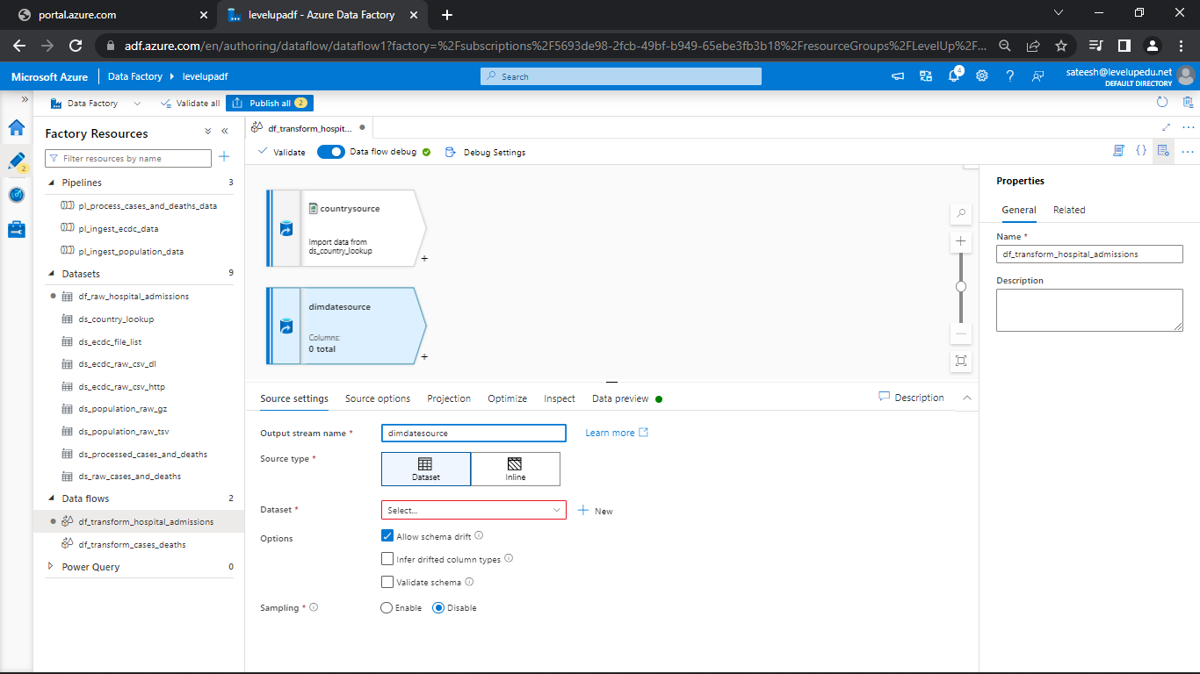

* Create a dataset for dimdate source

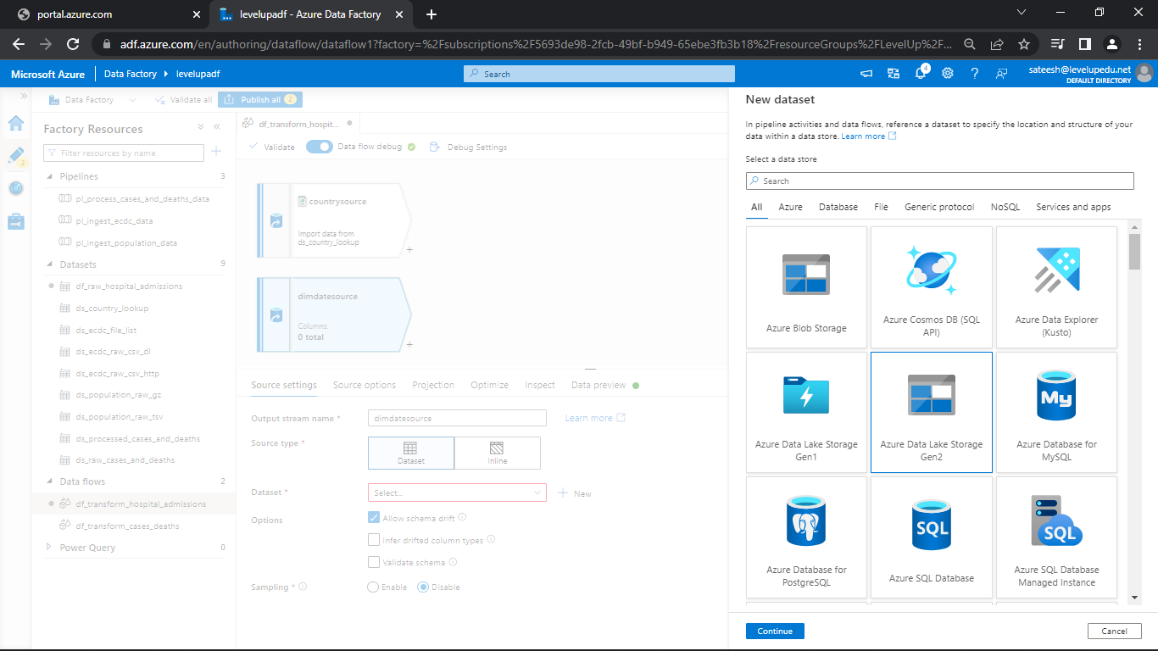

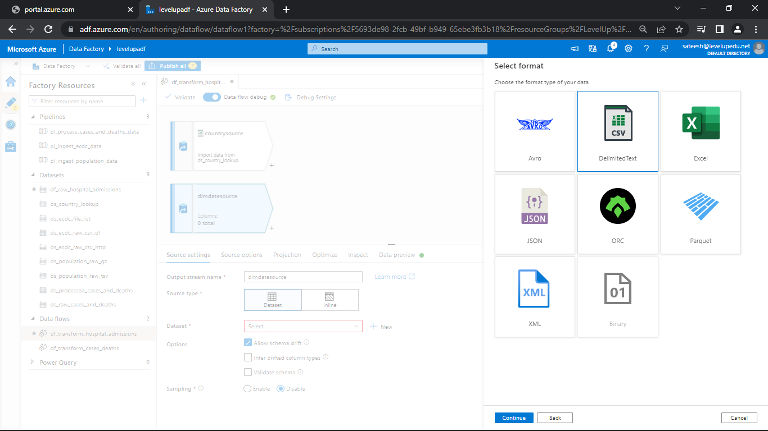

* Select the file that was uploaded in storage explorer

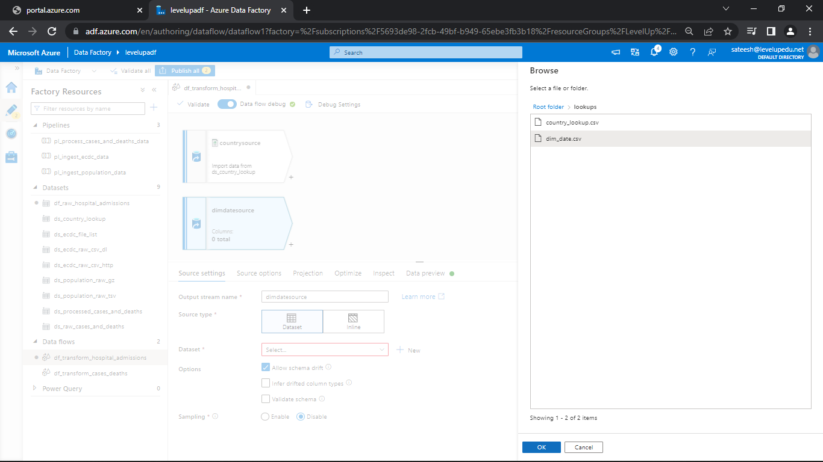

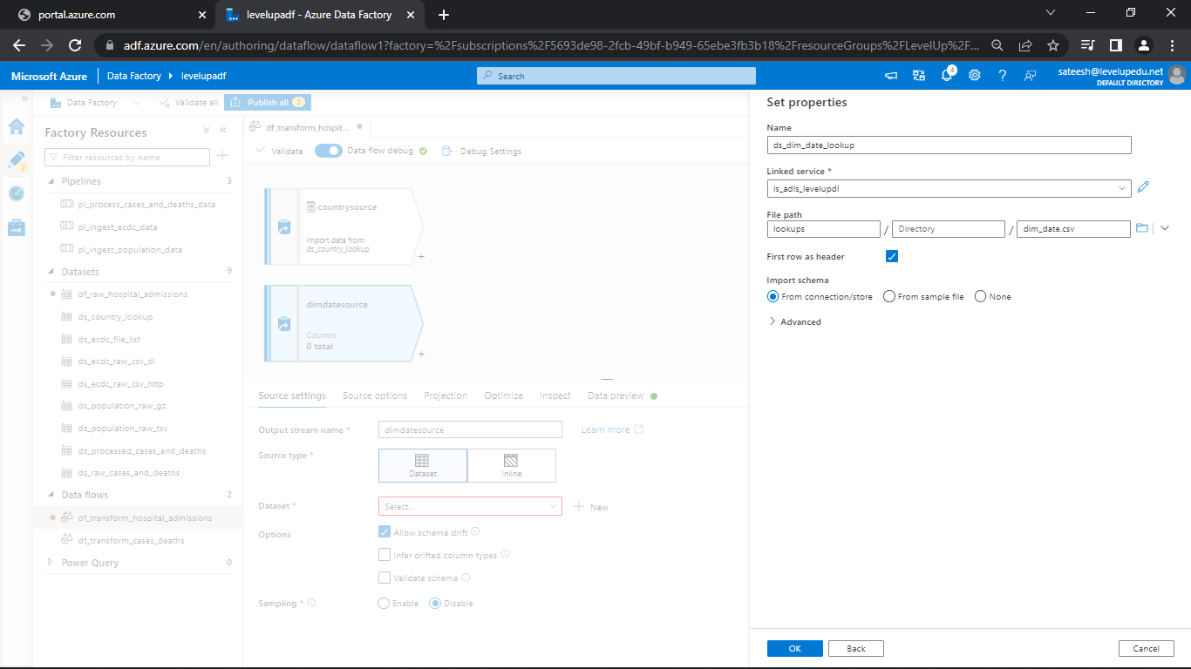

* Leave remaining as it is and go to data preview

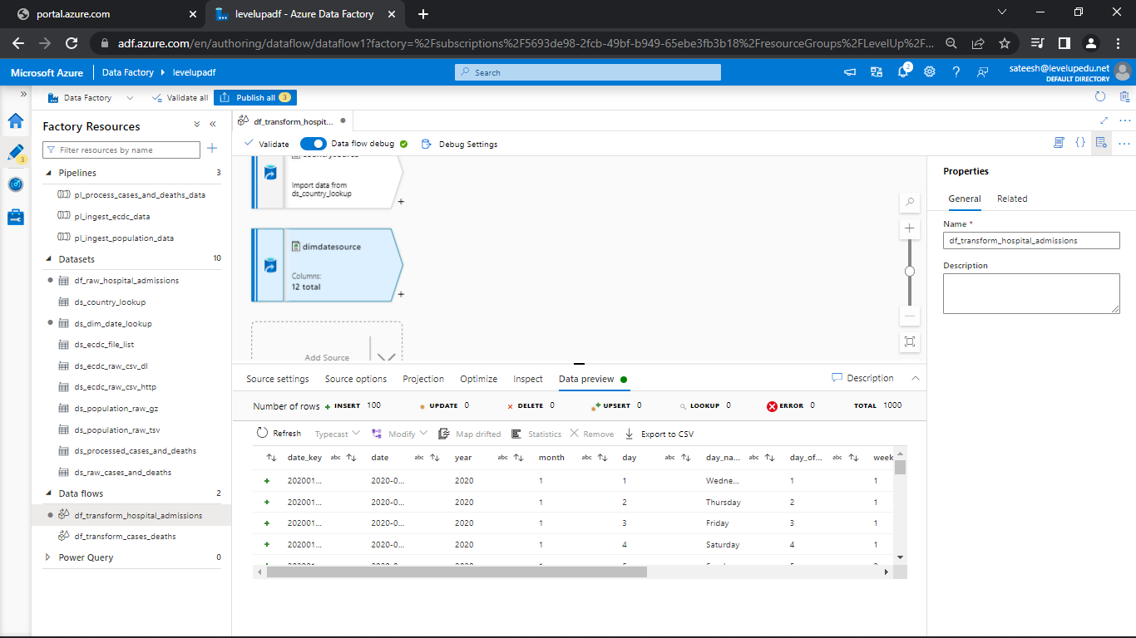

**Derived Column Transformation:**

* Let’s derive a new column by using year and week in the look up data
* Click on + next to dimdate and select derived column

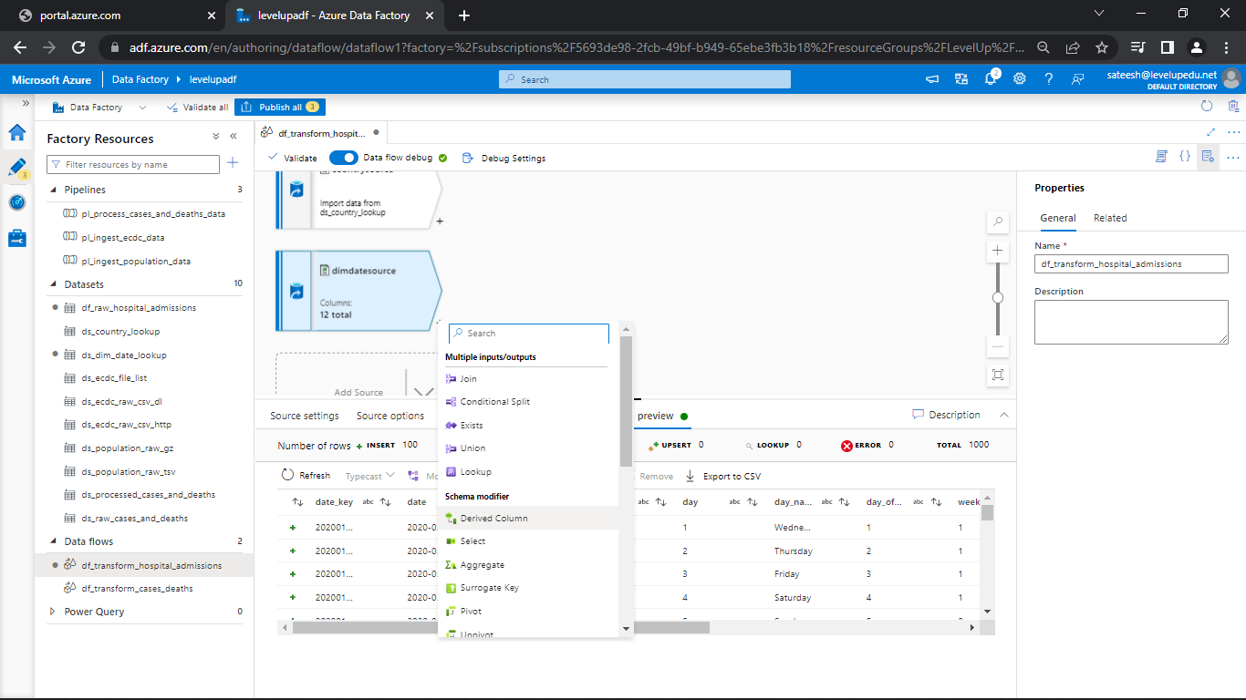

* Change the name if required
* Give the name of the column as ecdc_year_week and open expression builder

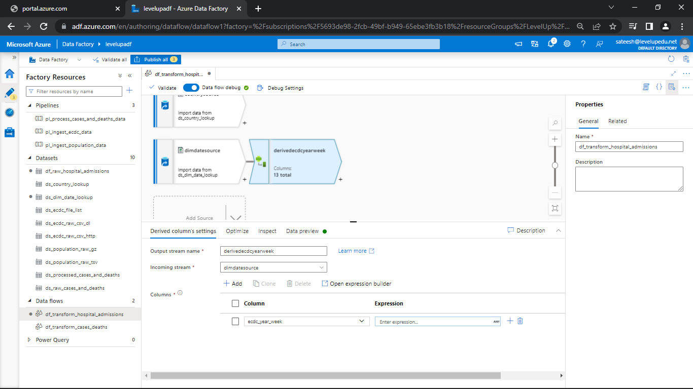

* Give this command in expression builder
* year + '-W' +lpad(week_of_year, 2, '0')

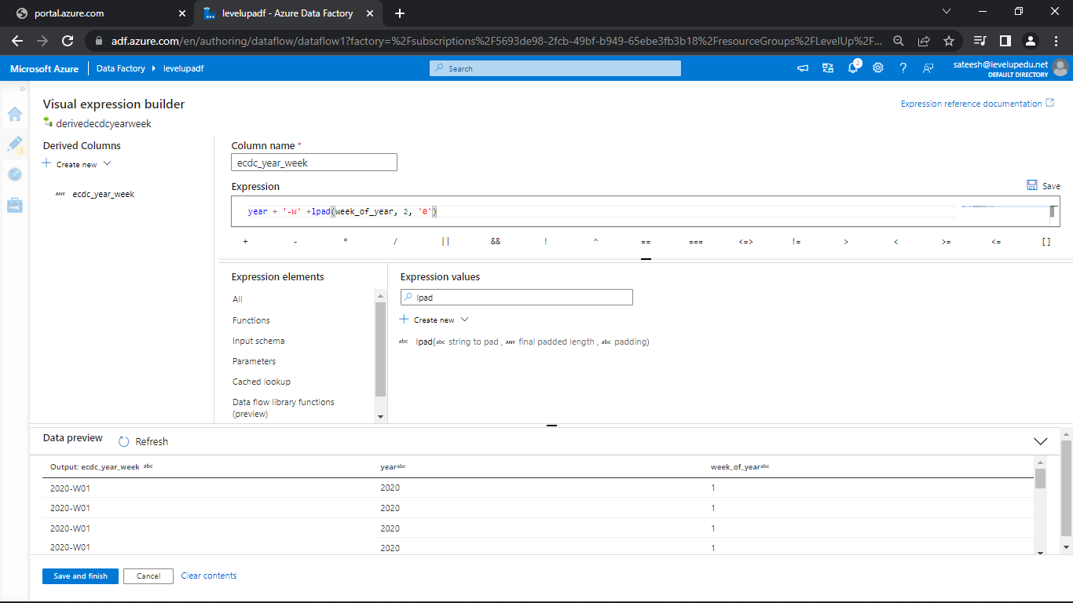

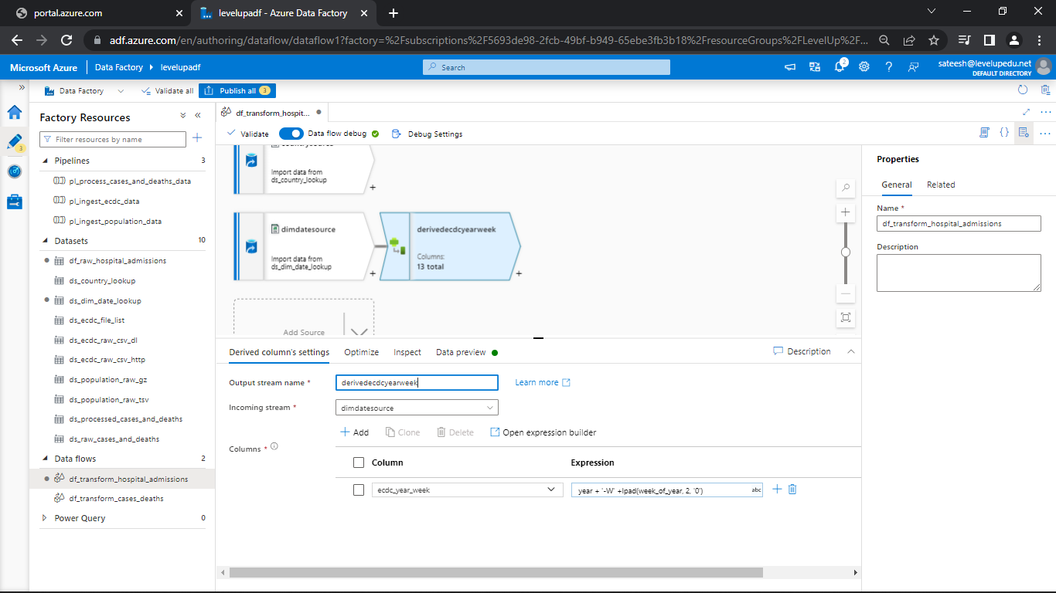

* Go to the data preview and leave remaining as it is

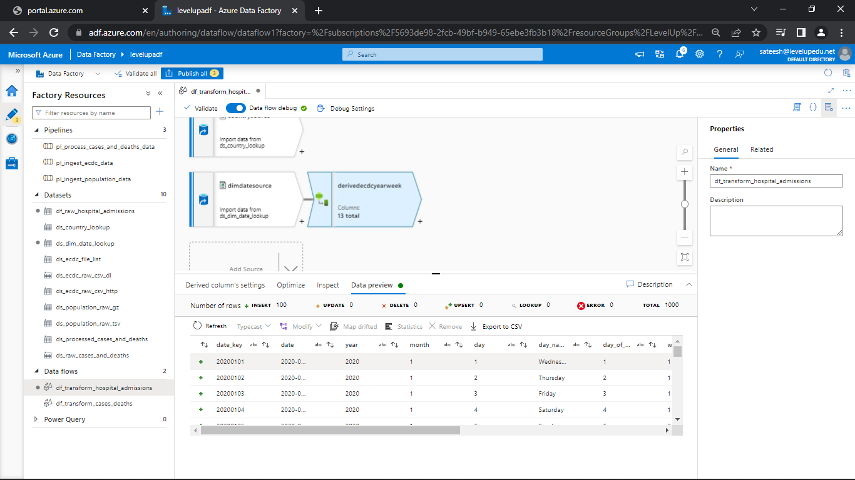

**Aggregate Transformation:**

* Click on + next to derived column transformation

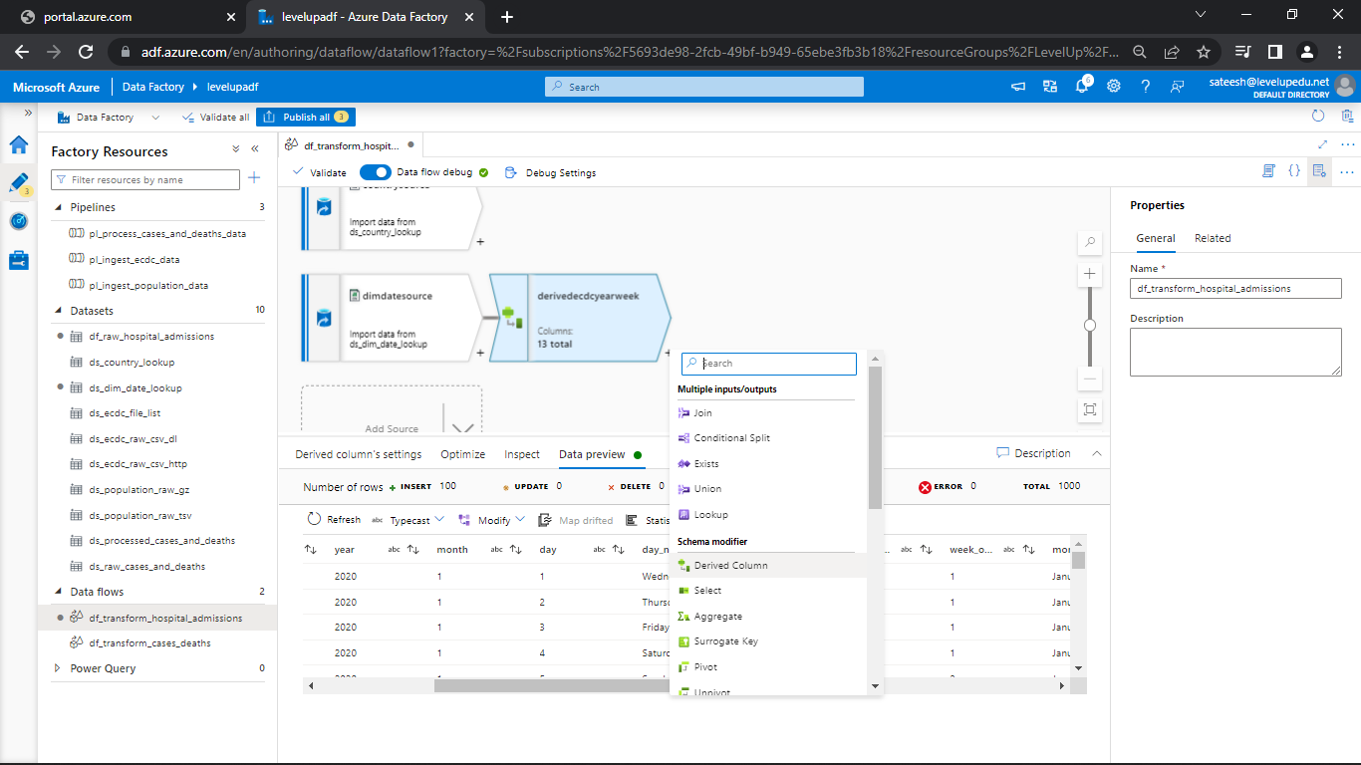

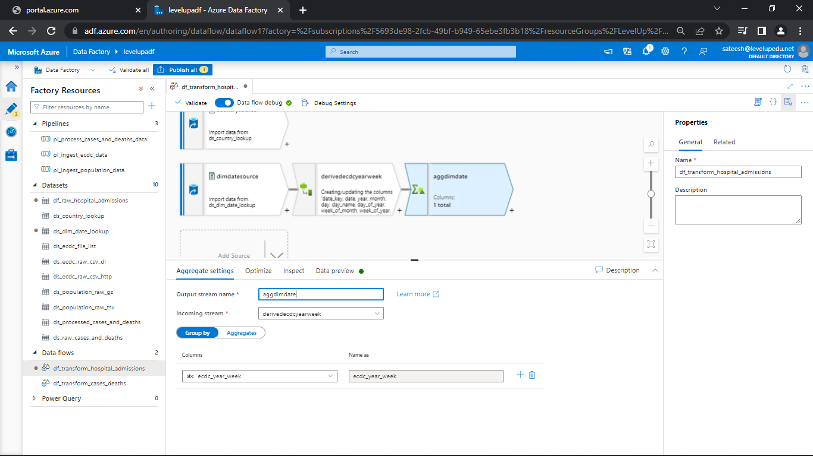

* Give the column name in groupby as ecdc_year_week and in aggregations type the column name as week_start_date and open the expression builder
* Give the command as min(date)
* And for week_end_date give the command as max(date)

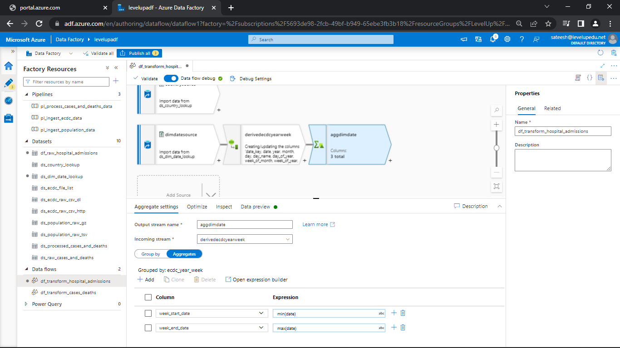

* You can see the derived columns in data preview

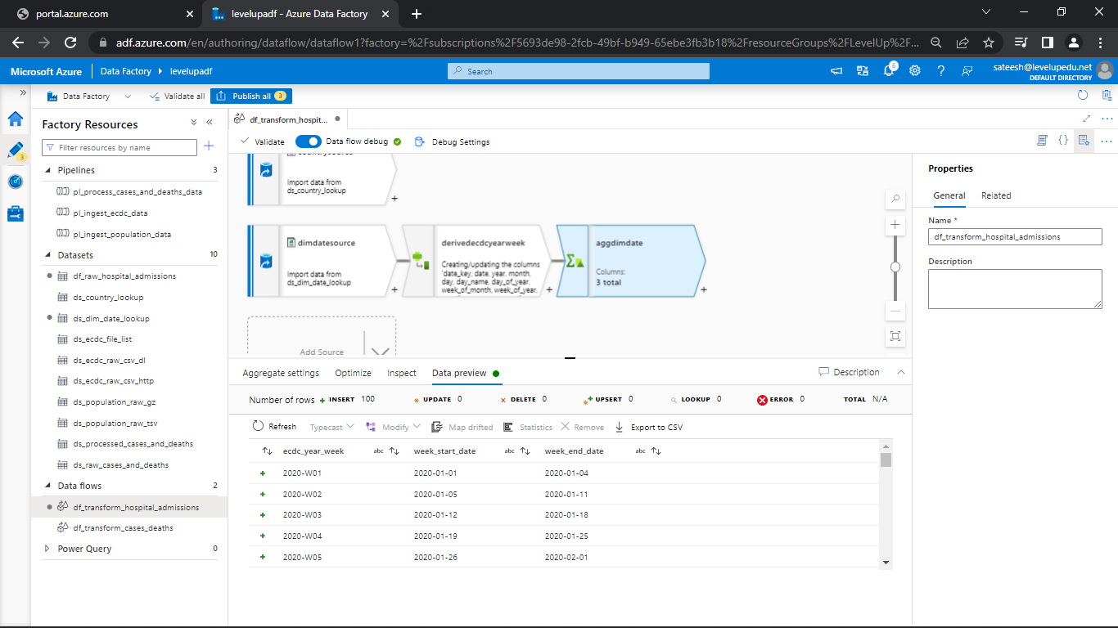

* Go to derived column and copy the expression that you have given

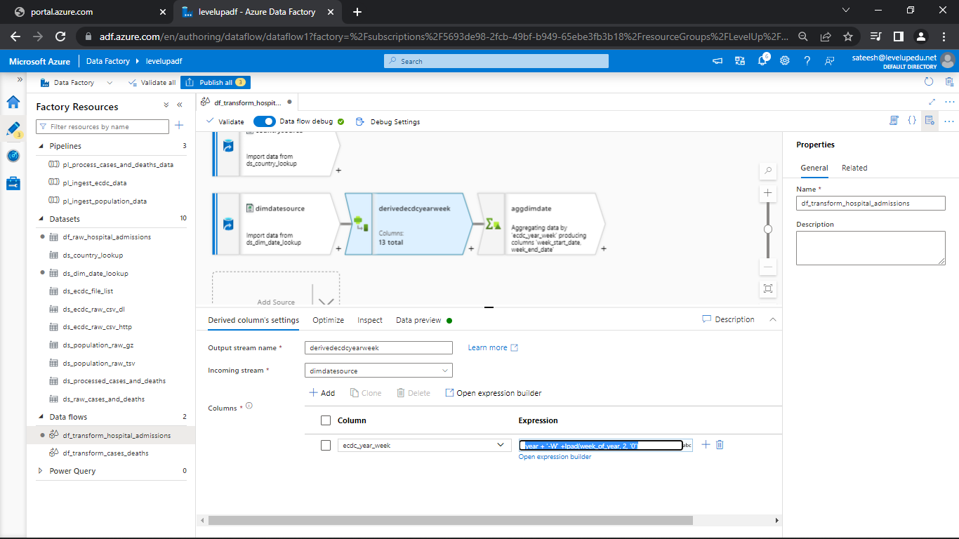

* Go to aggregate transformation and paste that in group by column

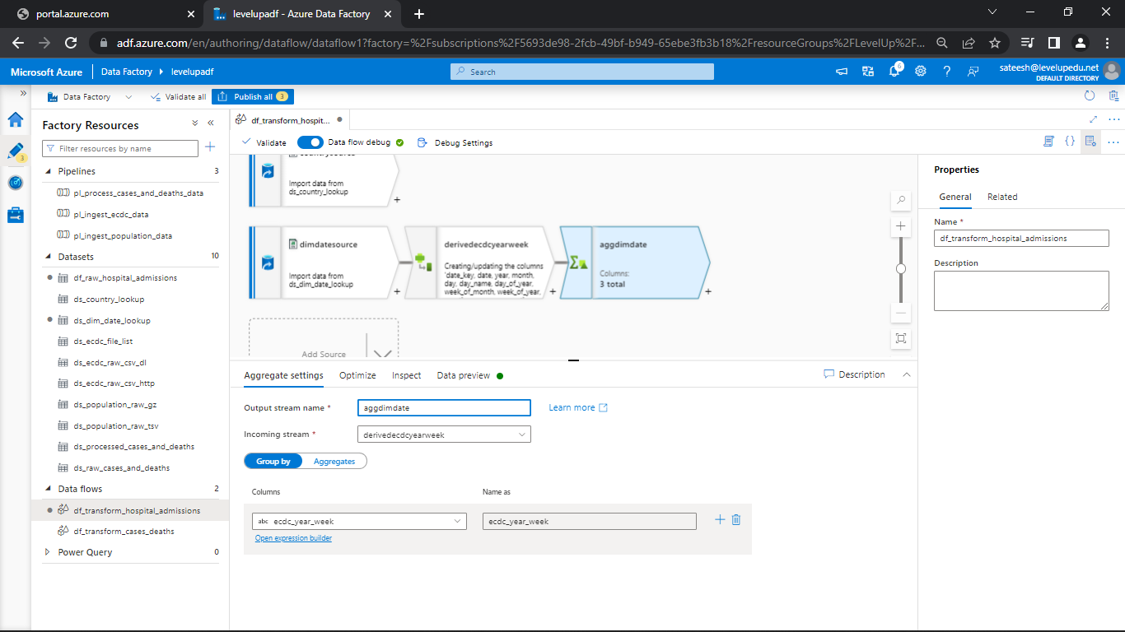

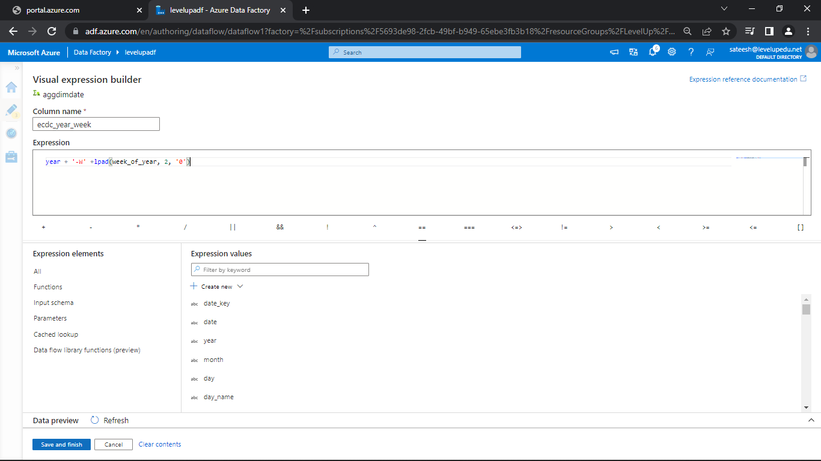

* Click on save and finish
* Before that delete the derived column transformation and check the data preview in aggregate transformation
* You can see the columns as well.

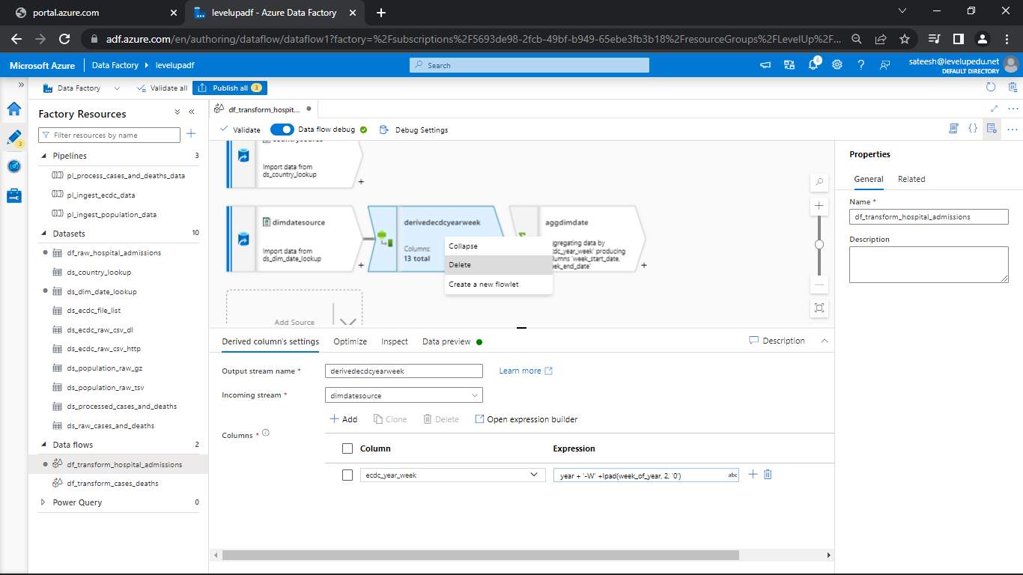

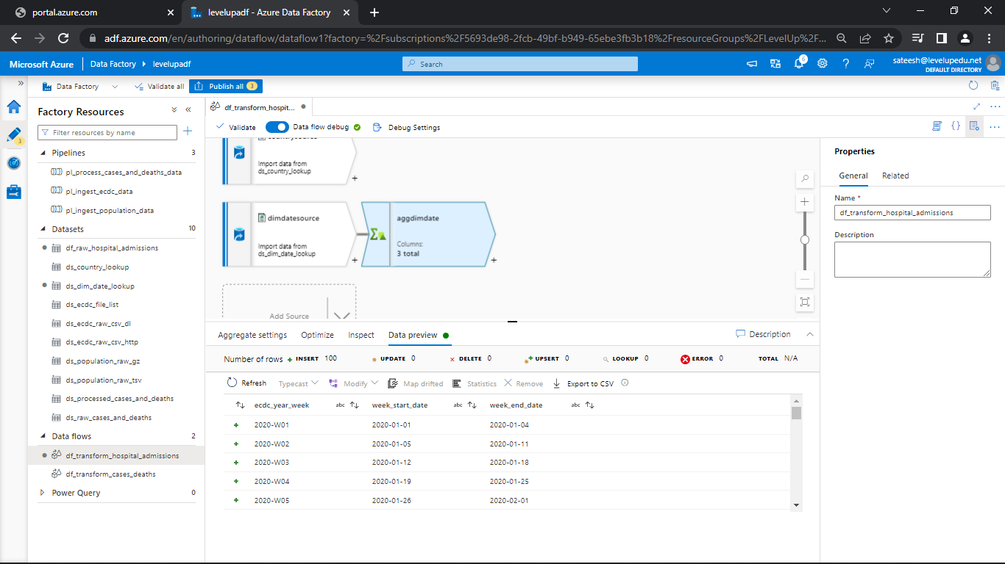

**Join Transformation:**

* We need to join the weekly data to dim date source
* As for the joins we need to have left and right stream data
* So, for the right stream data use aggdimdate
* Select the join conditions

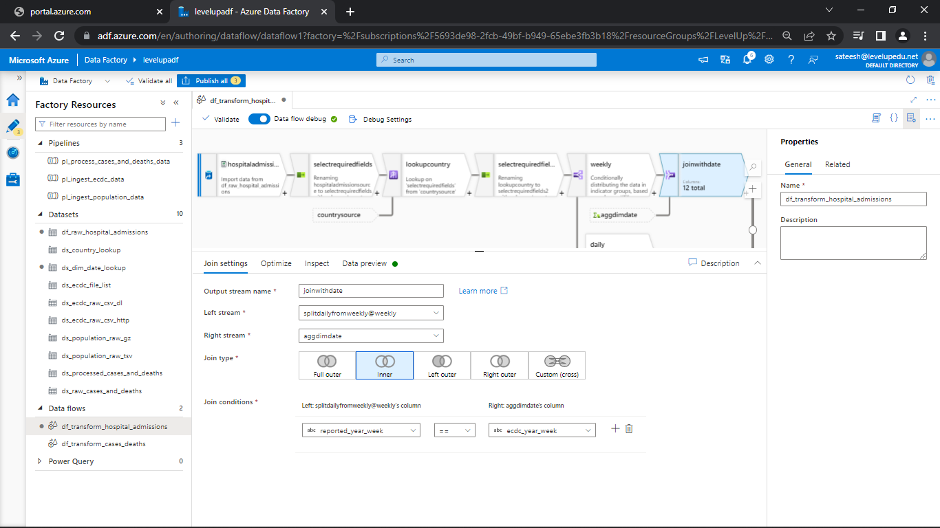

**Pivot Transformation:**

* Click on + and add pivot transformation

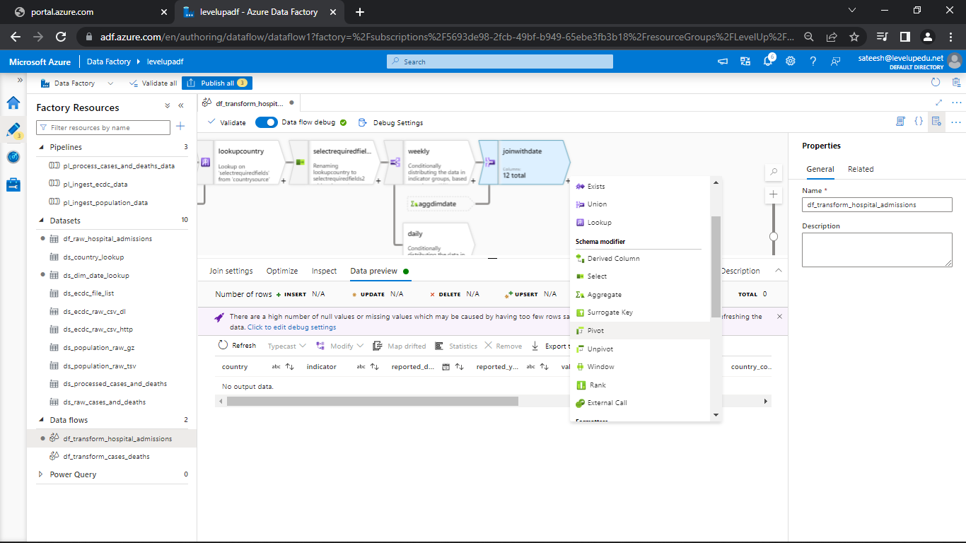

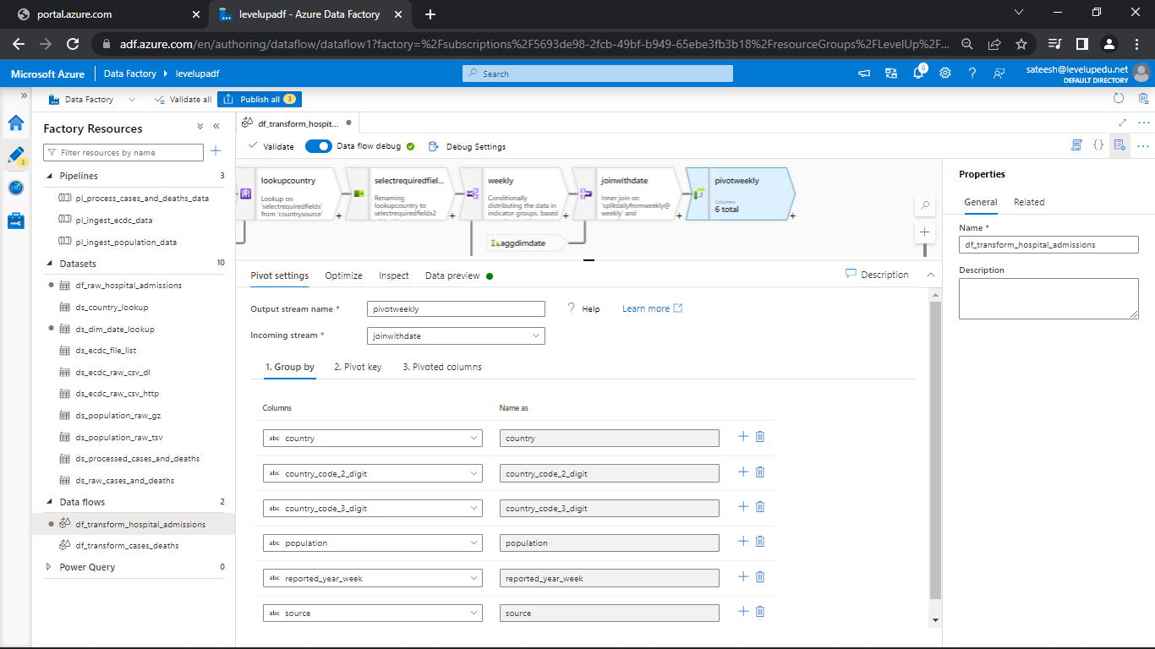

* Go to pivot key

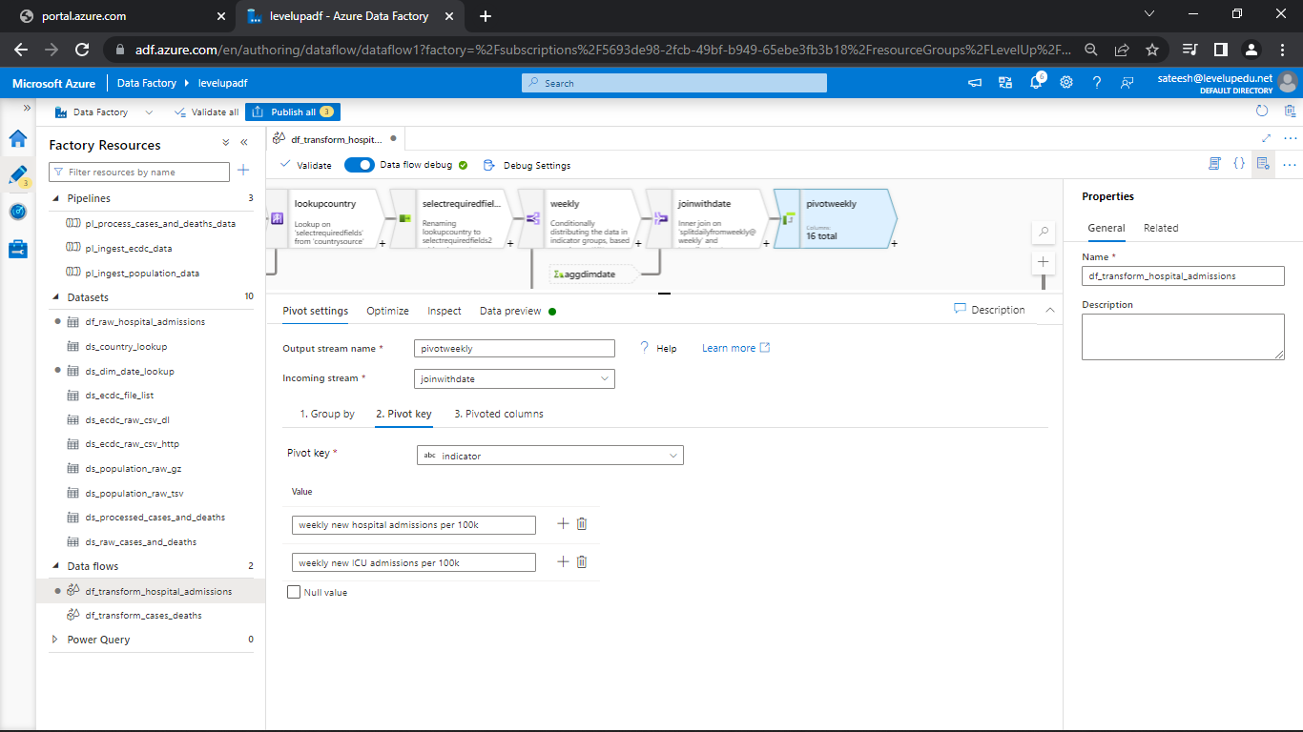

* Go to pivoted columns

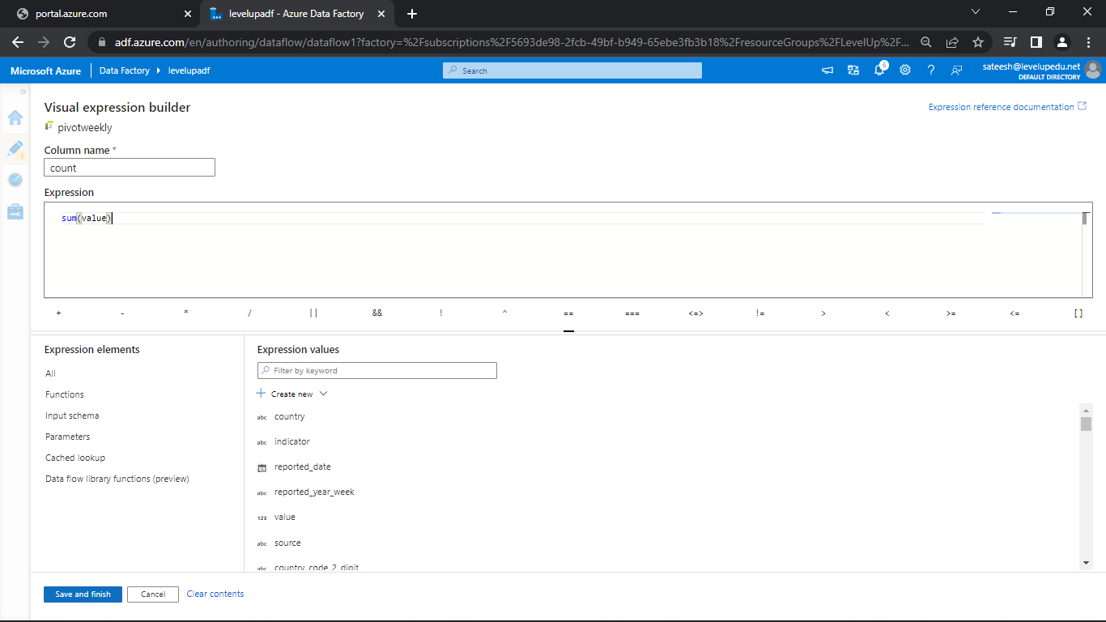

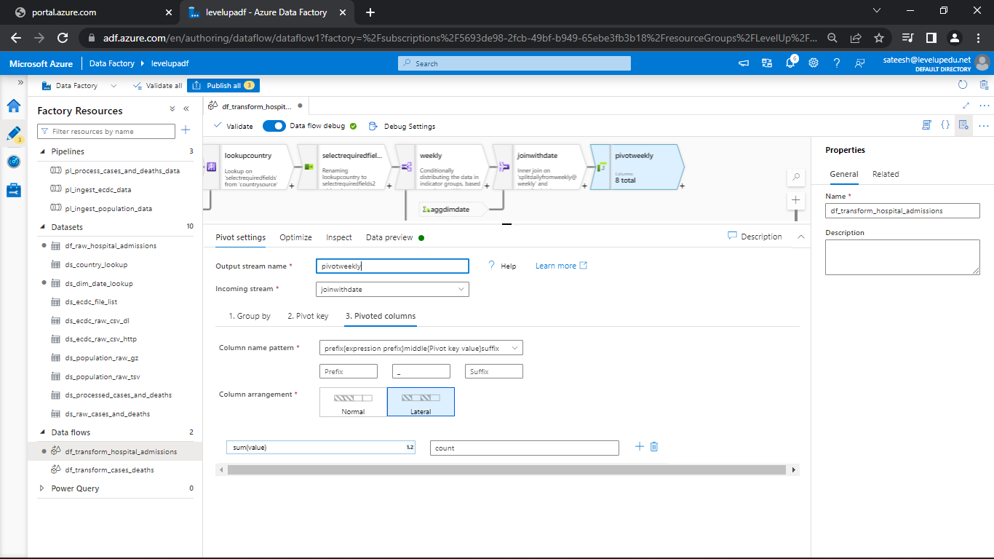

* Go to data preview
* Now let’s create a daily activity

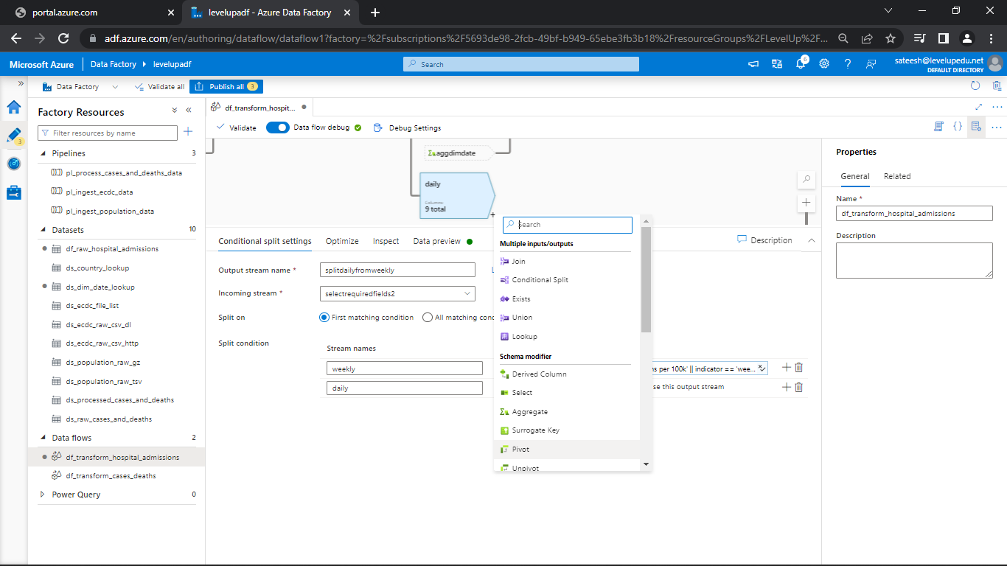

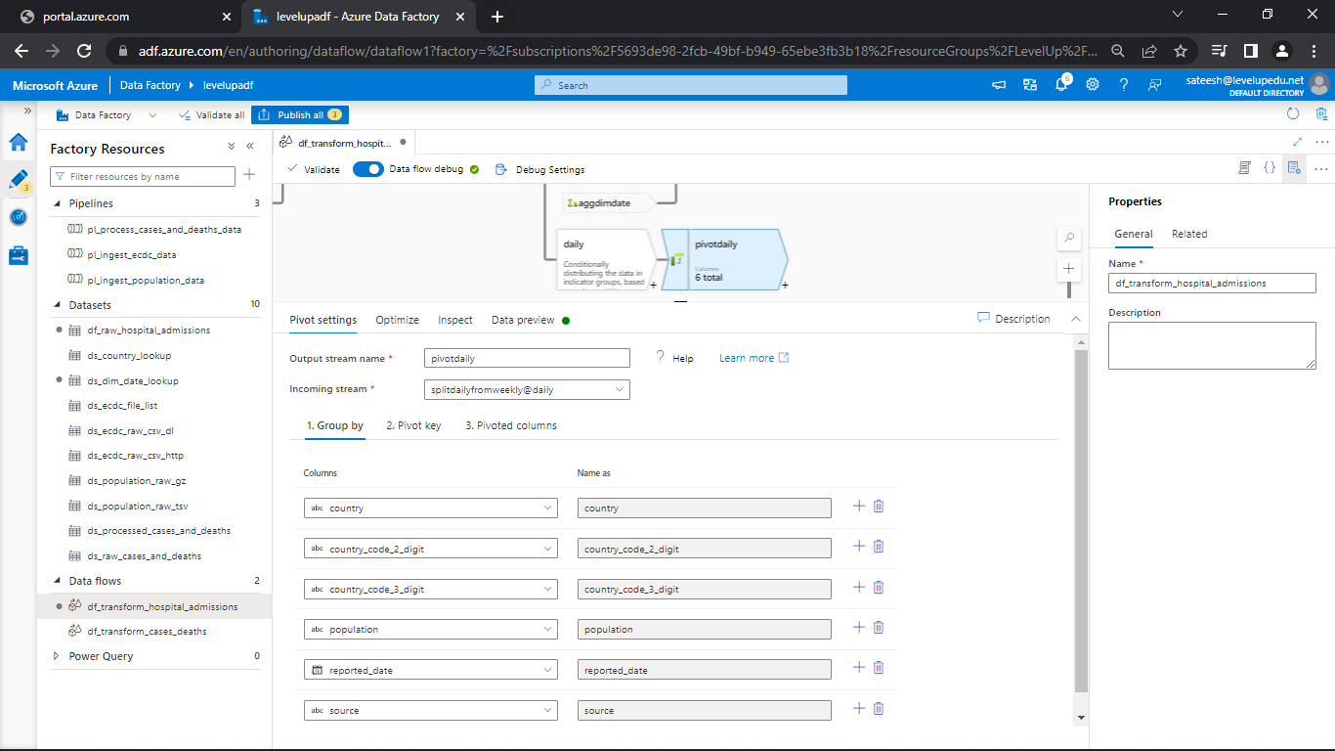

* Go to pivot key and add the columns

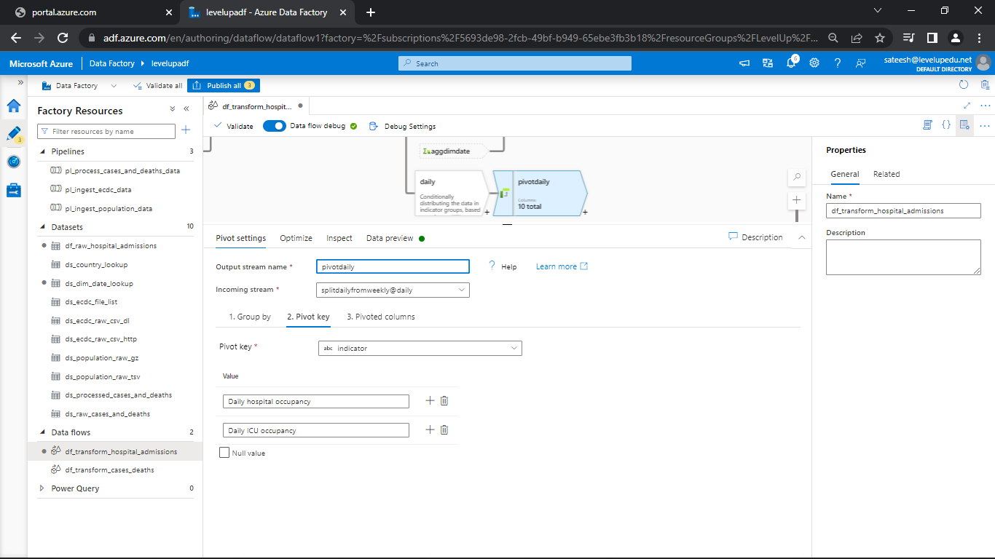

* Go to pivoted columns and add sum(value) as expression builder

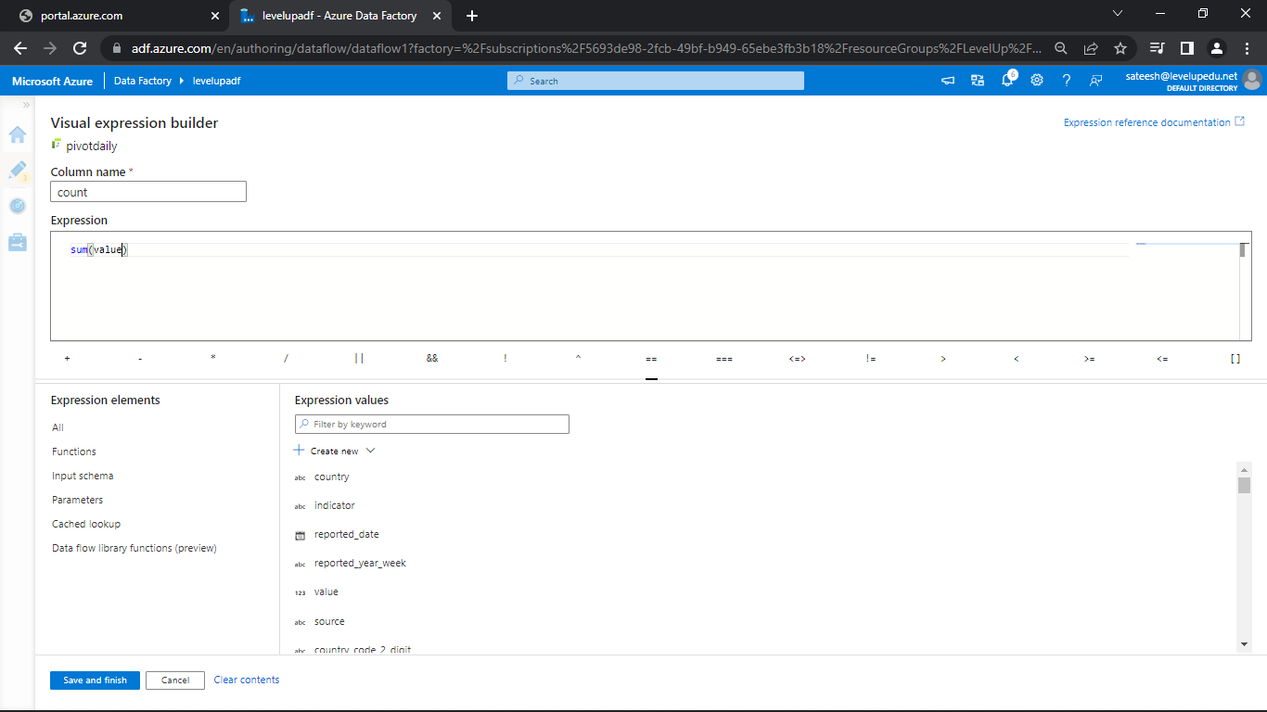

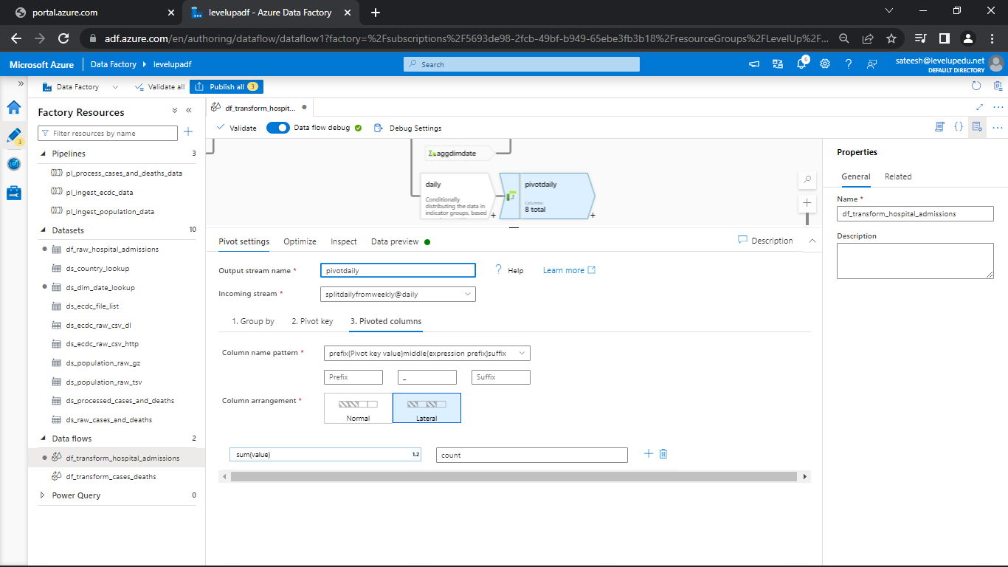

* Go to data preview

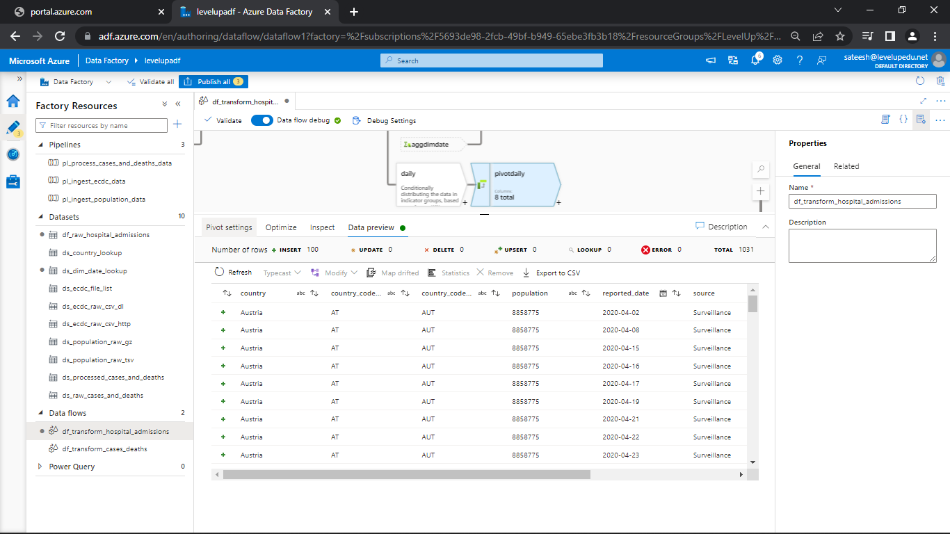

**Sort Transformation:**

* We want to sort the daily data in ascending order so let’s sort the data using sort transformation
* Click on + and add sort transformation

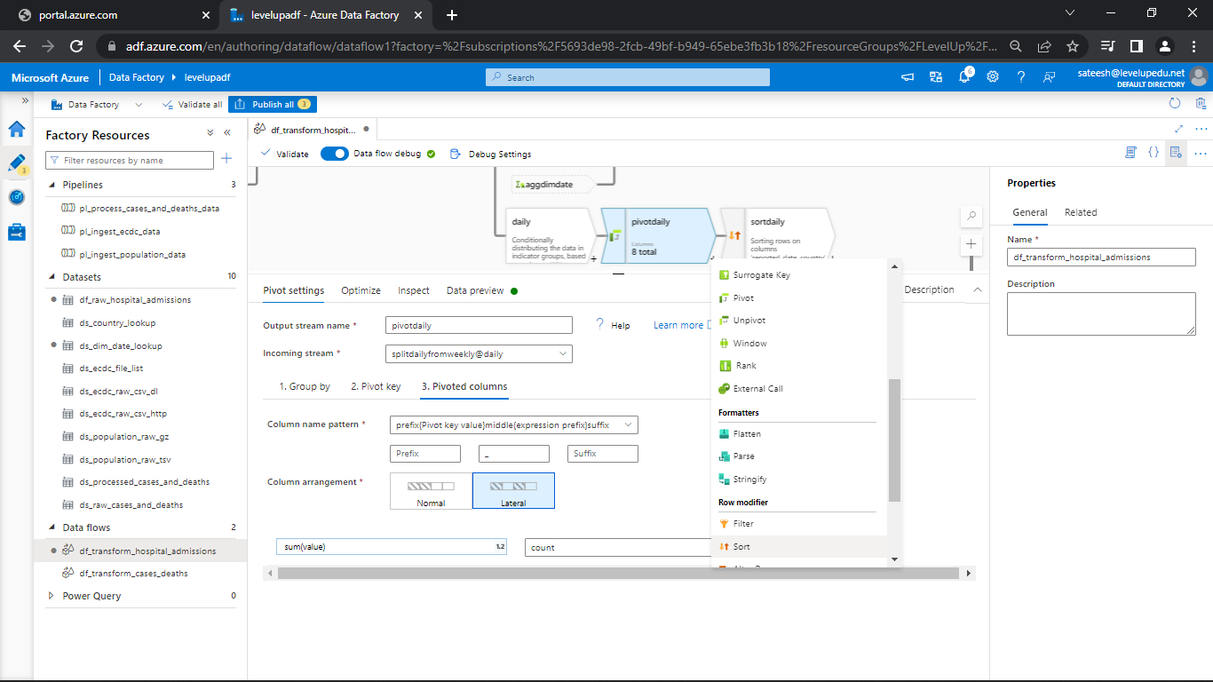

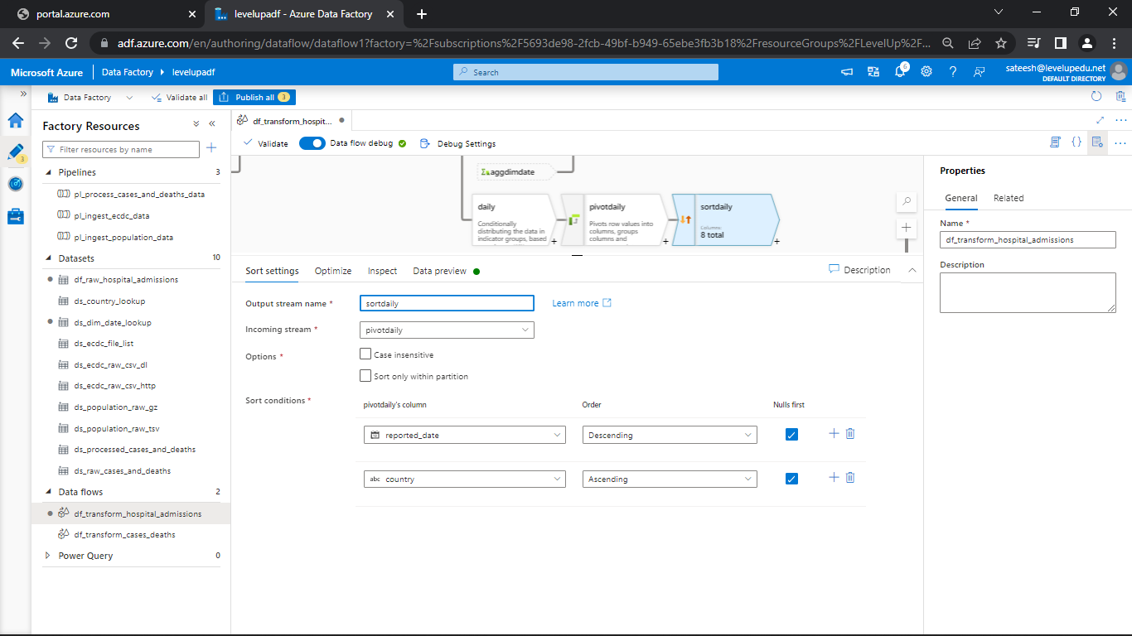

* Get the reported year data descending and country as ascending
* Go to data preview and see the sorted data

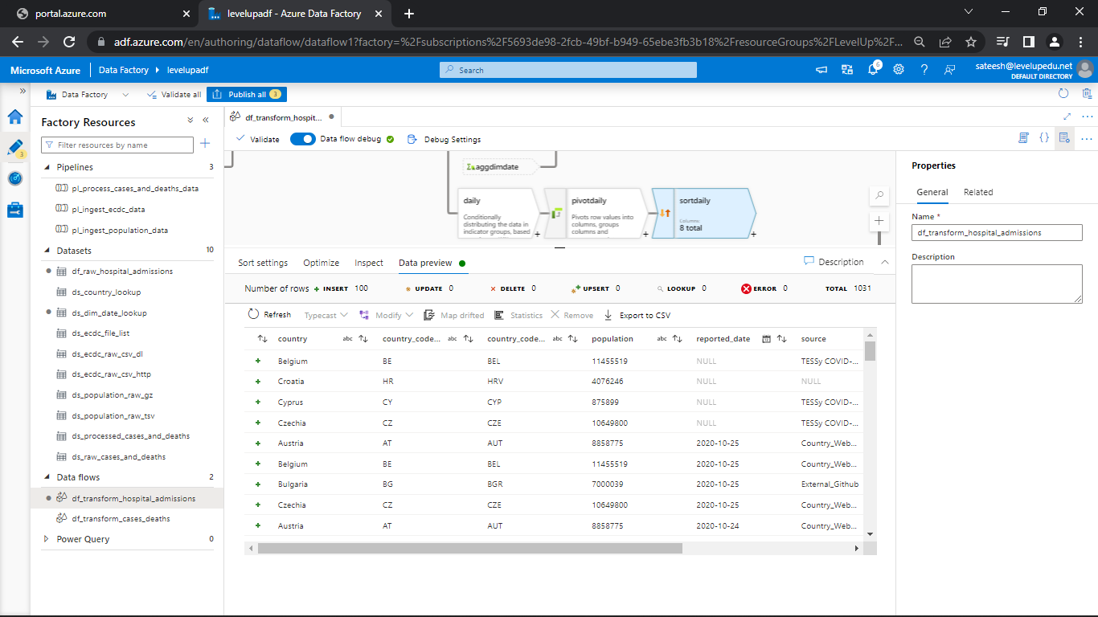

**Select Transformation:**

* Trying select transformation daily file
* You try for weekly data
* Let’s add select transformation for sort daily

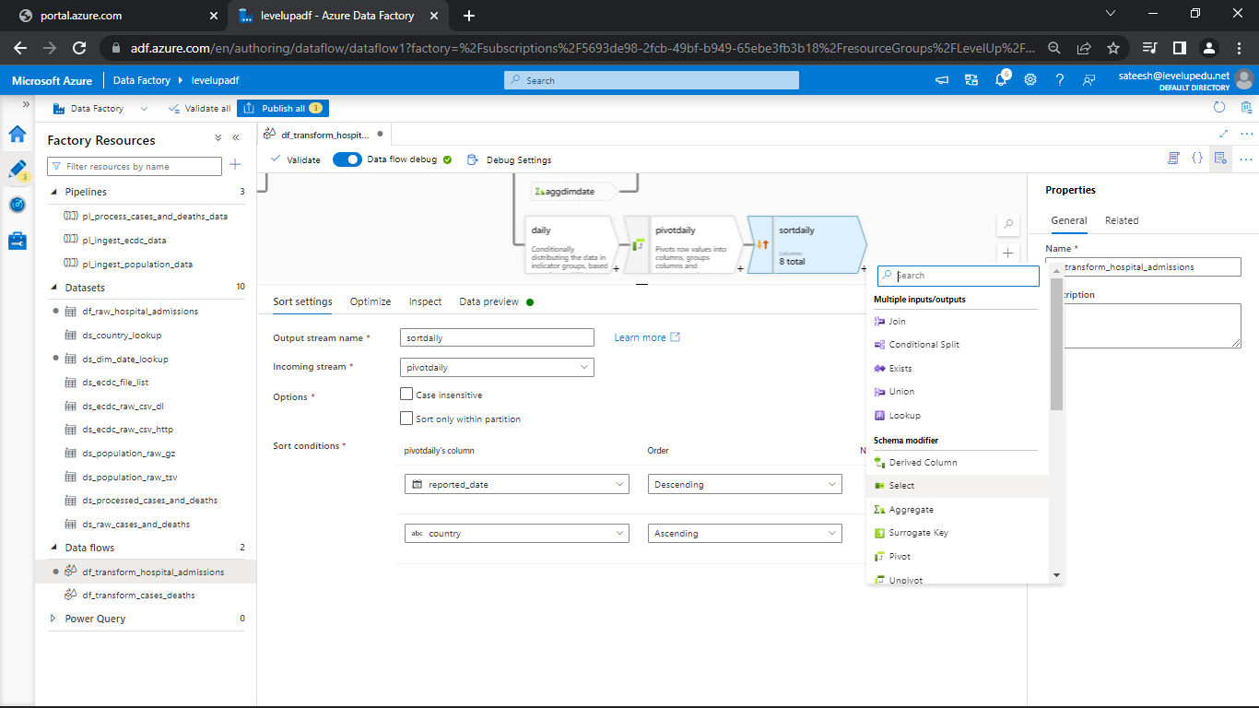

* Change the names if required

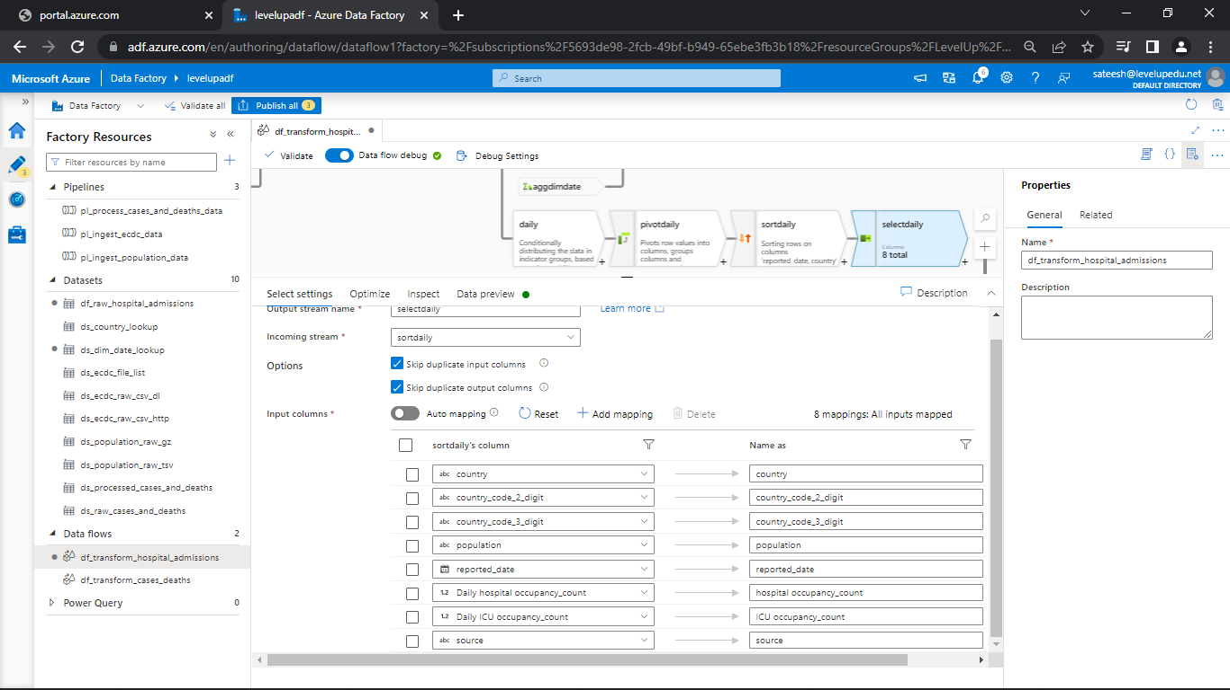

* Create a sink dataset for both daily and weekly

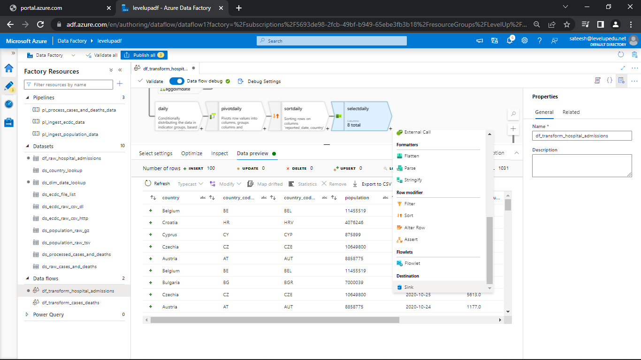

* Create a dataset for both separately

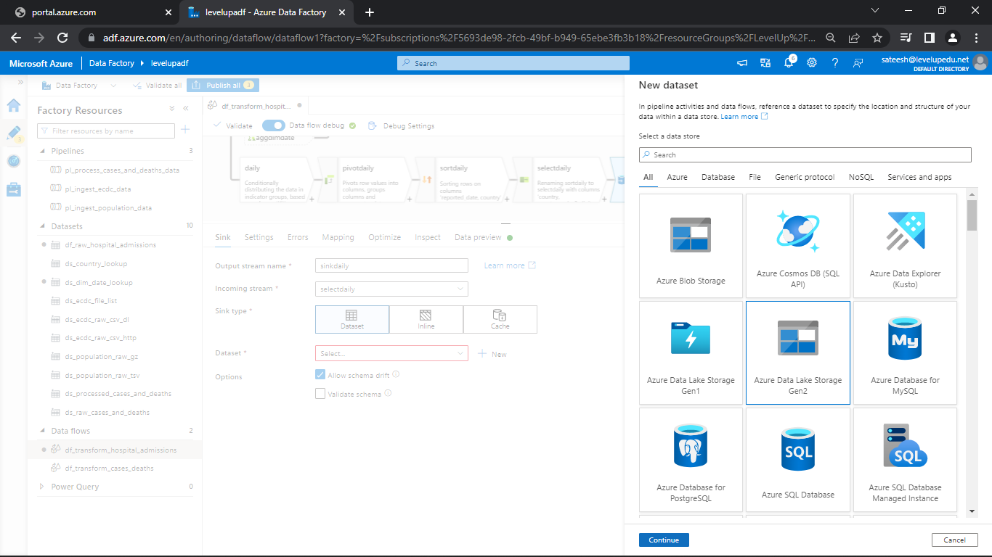

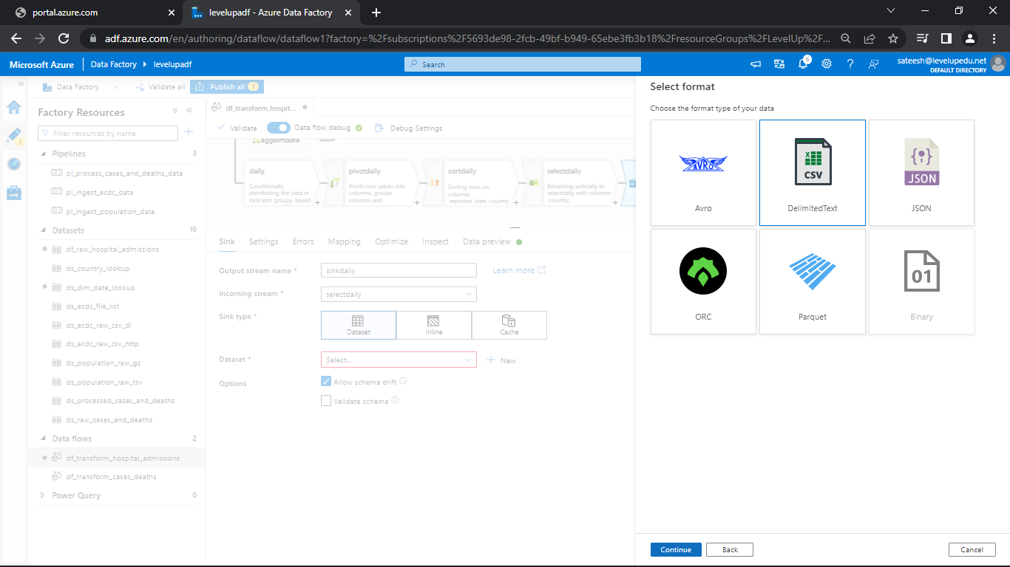

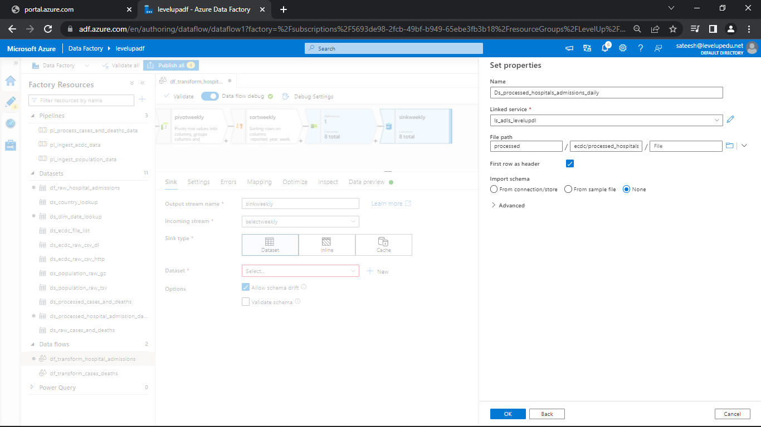

* Later import the file path and see the output in data preview

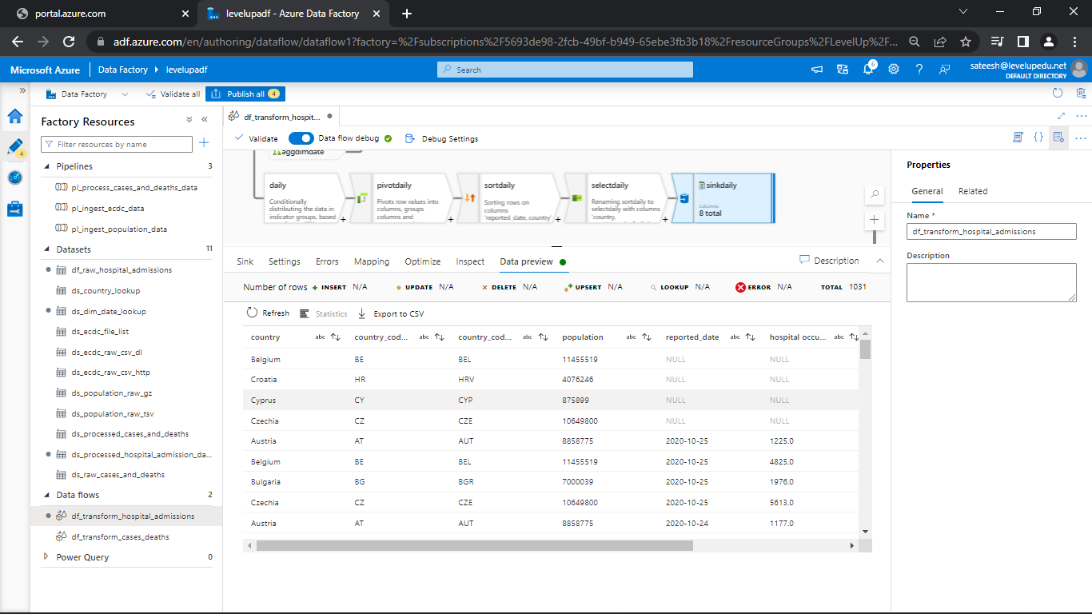

**Create ADF Pipeline:**

* Create a new pipeline

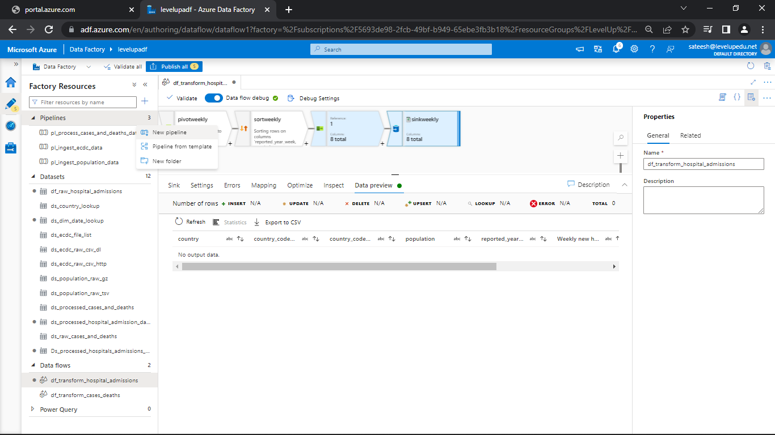

* Drag data flow to the pipeline pane and select path as hospital_admissions_data in settings

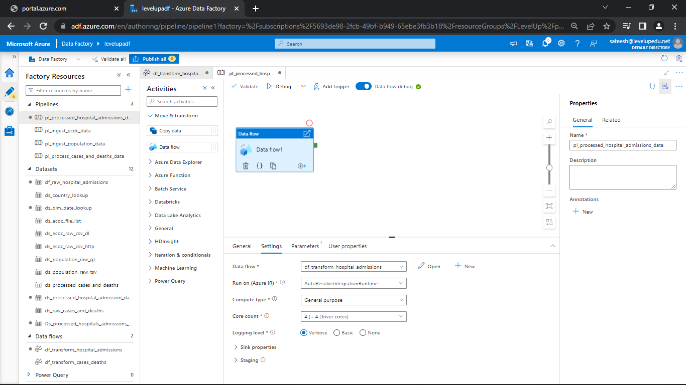

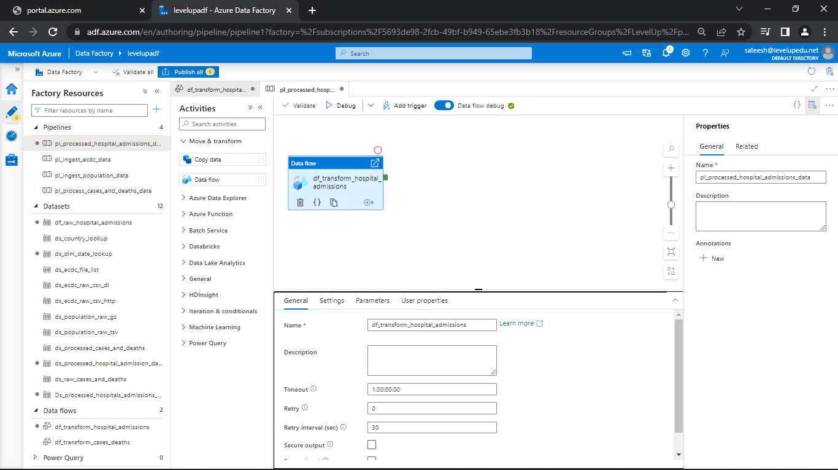

* Now, publish all

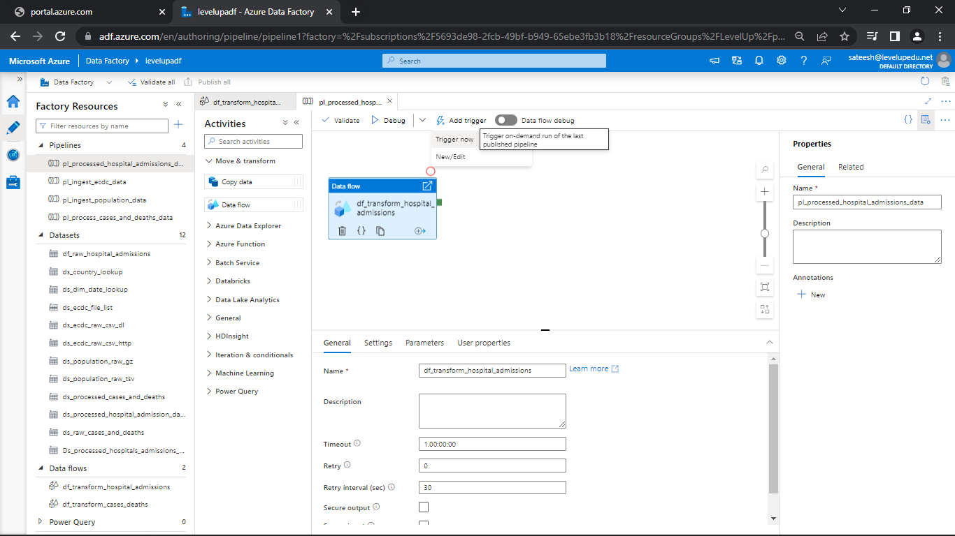

* Click on trigger now and add trigger
* Now, go to pipeline and see the data process

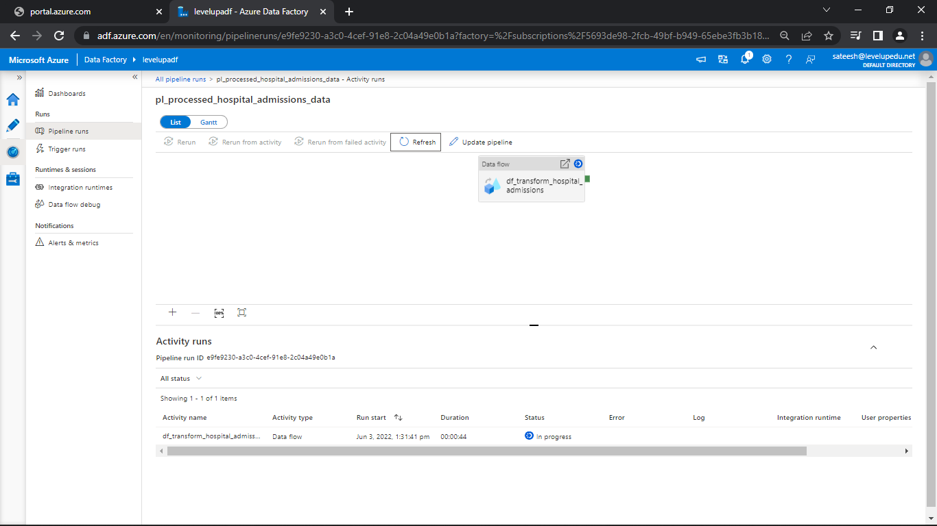

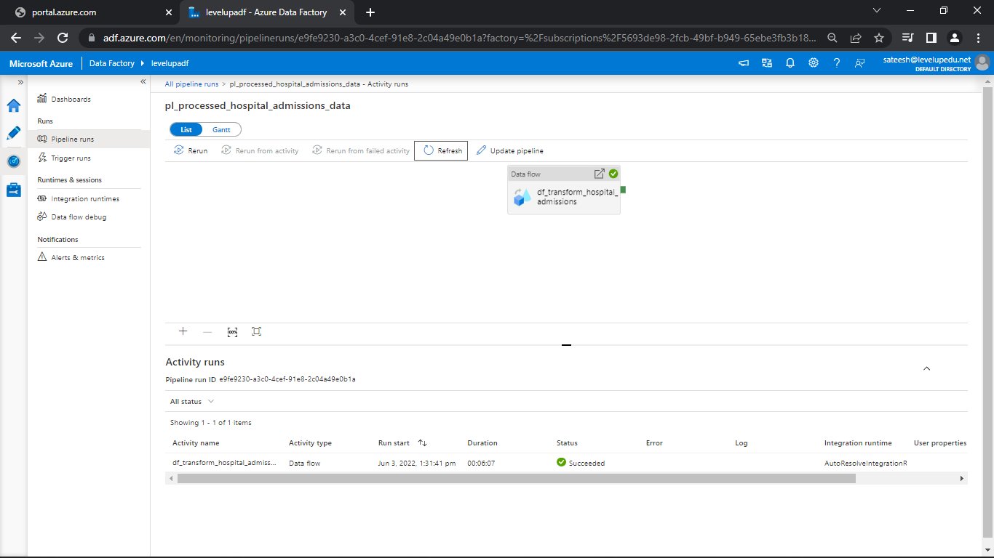

* Go and see data in storage explorer for both daily and weekly data
* There are plenty of files

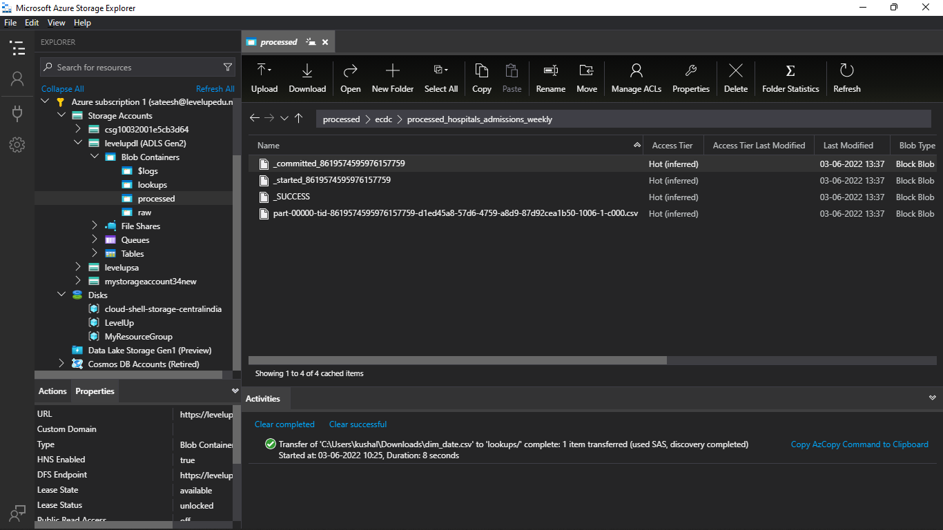

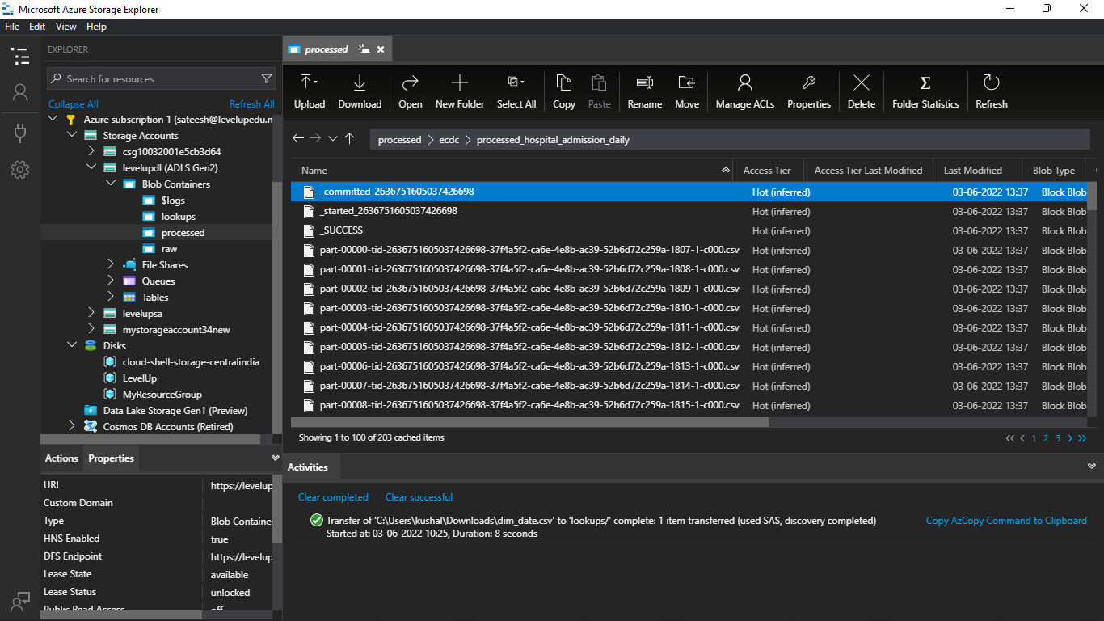

* Go the data flow and in sink select optimize and set to single partition

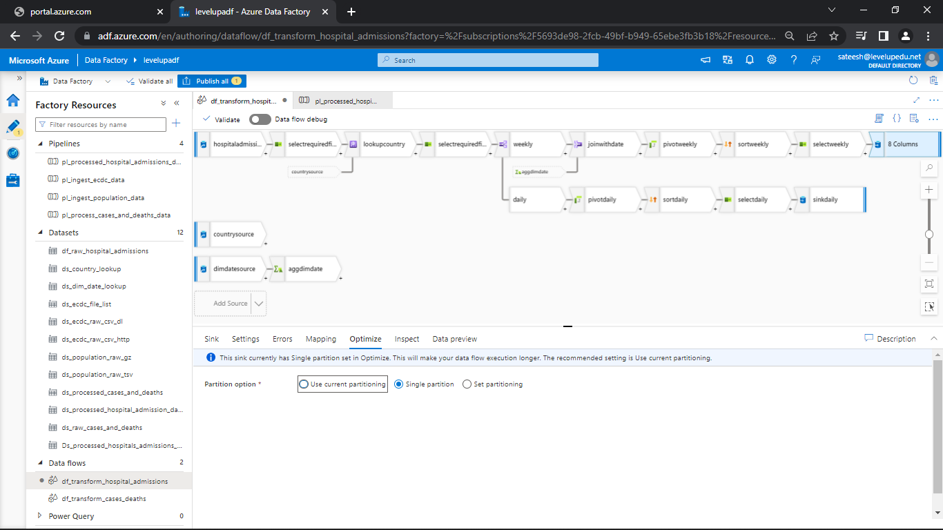

* Go to settings and change the file name to output to single file
* And type the filename as required.

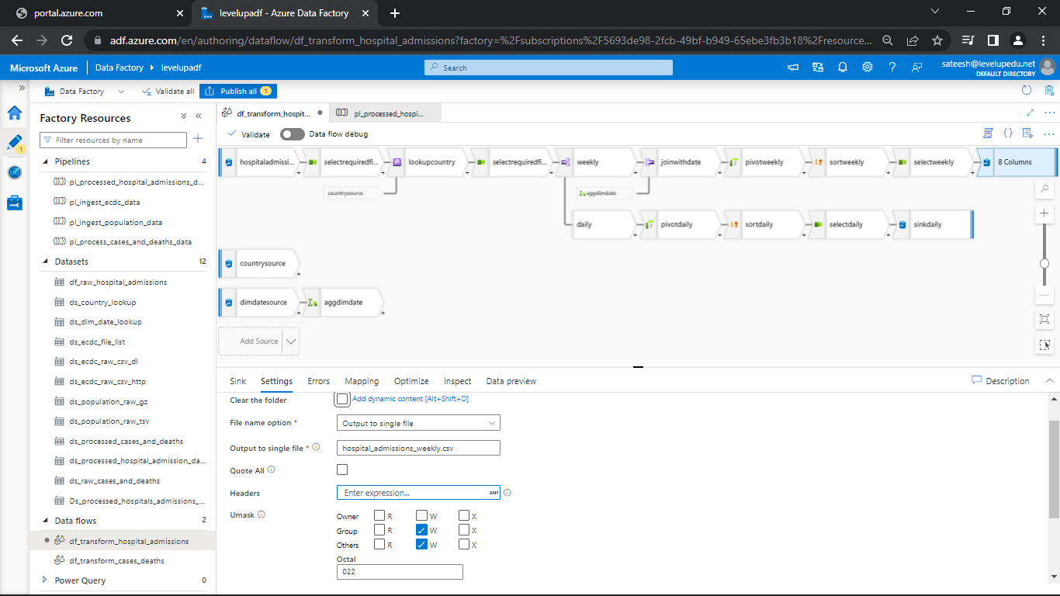

* We need to change the sort as well to single partition

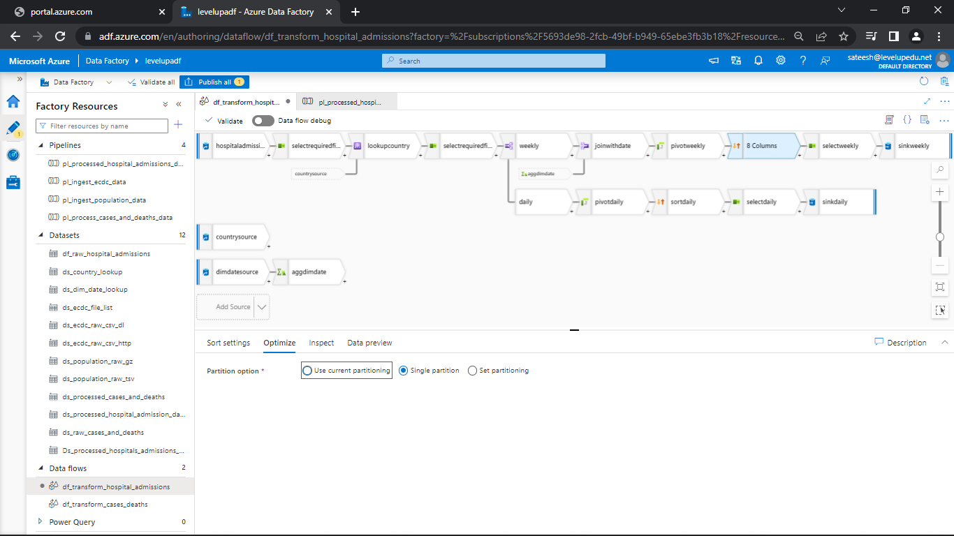

* Later, publish all so that all the changes are saved
* Go to the pipeline and click on trigger

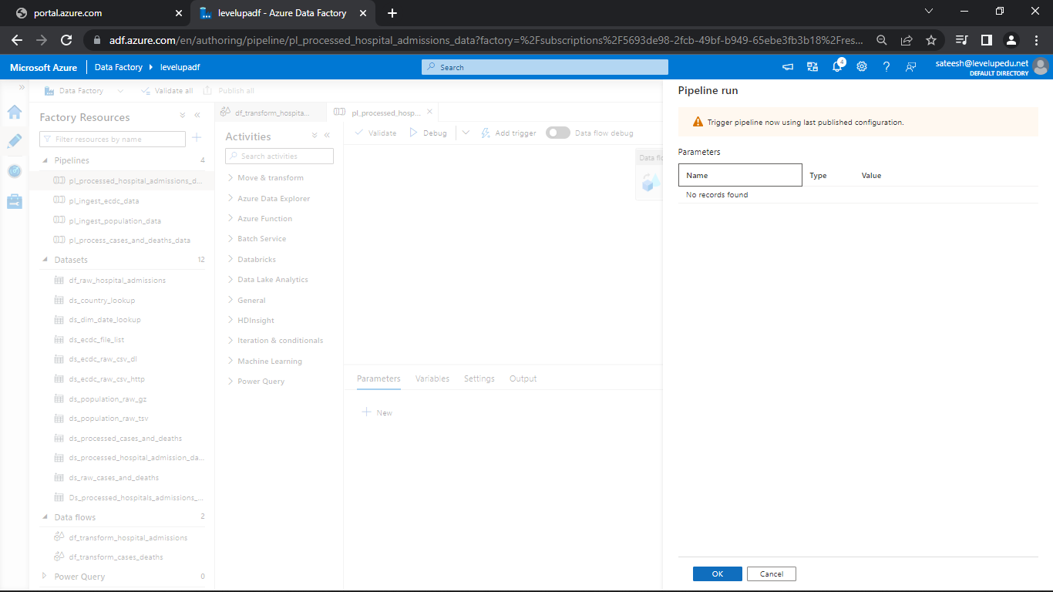

* See the pipeline got succeeded

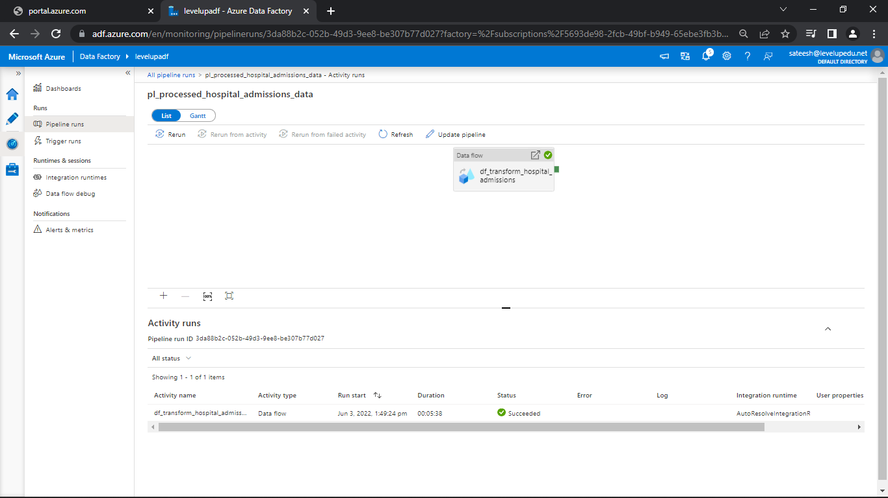

* Go to storage explorer and see the data present in the folder is of a single file

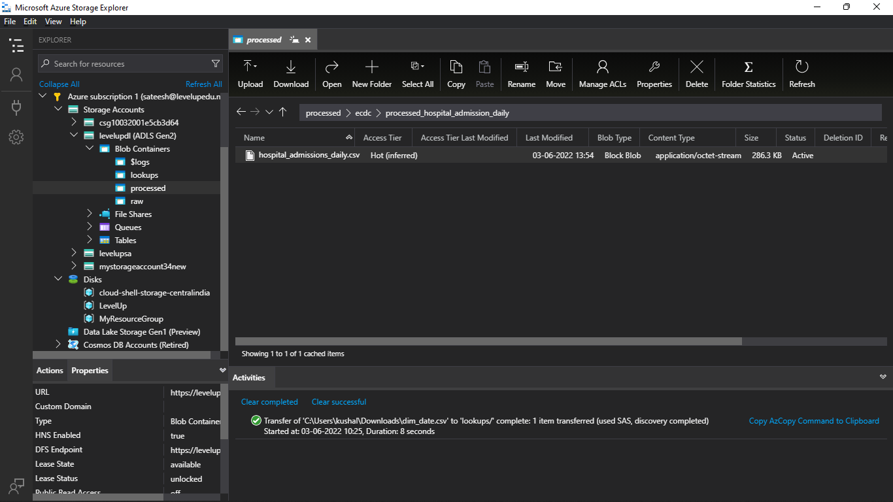

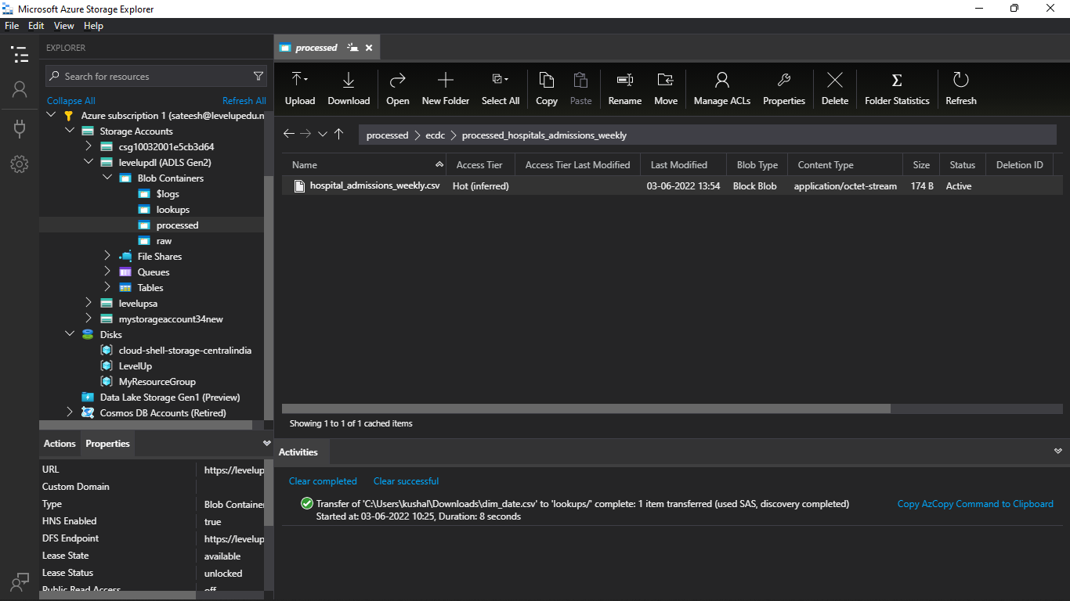

**Data Flow - Hospital Admissions Data Transformation**

Lecture: Conditional Split Transformation

Overview - <https://docs.microsoft.com/en-us/azure/data-factory/data-flow-conditional-split>

Lecture: Derived Column Transformation

Overview - <https://docs.microsoft.com/en-us/azure/data-factory/data-flow-derived-column>

Lecture: Aggregate Transformation

Overview - <https://docs.microsoft.com/en-us/azure/data-factory/data-flow-aggregate>

Lecture: Join Transformation

Overview - <https://docs.microsoft.com/en-us/azure/data-factory/data-flow-join>

Lecture: Sort Transformation

Overview - <https://docs.microsoft.com/en-us/azure/data-factory/data-flow-sort>